Alzheimer's Congressional Visual Package
Prepared for Girard “Jerry” Perone | Congressional Edition visuals

01 US Alzheimers Growth Curve
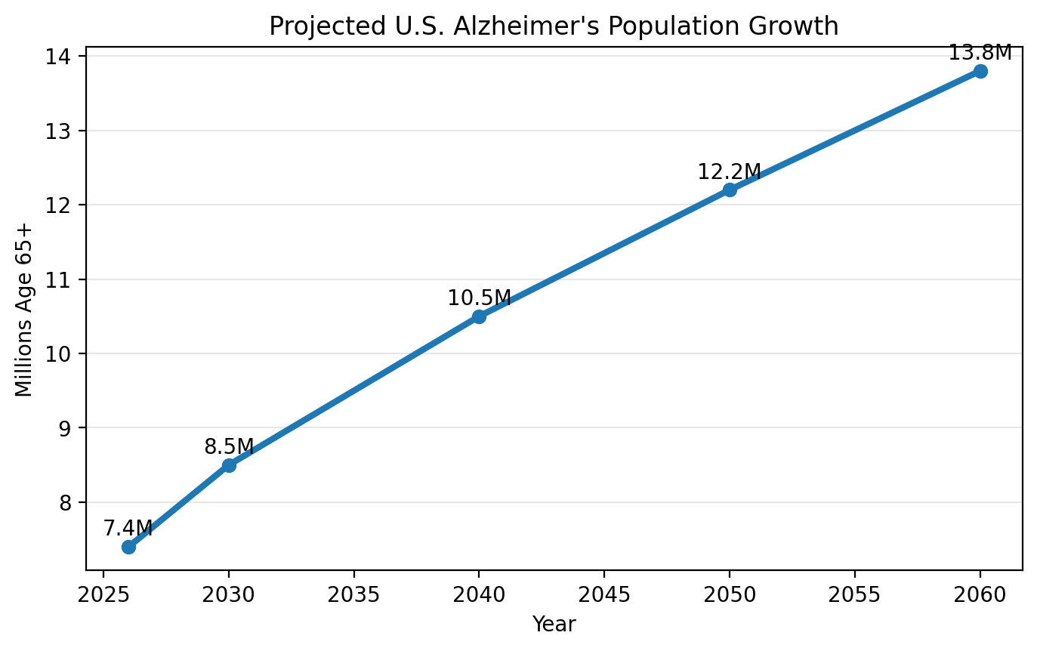

02 Hawaii Burden Dashboard
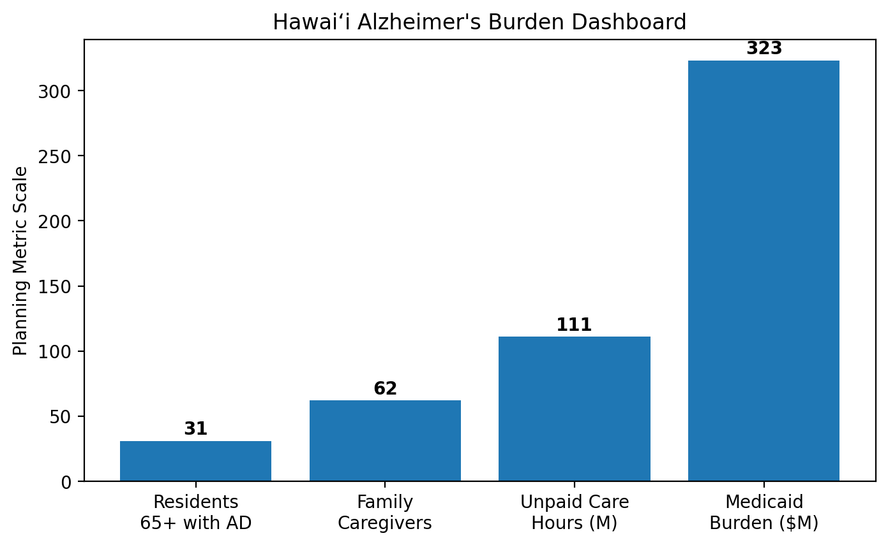

03 ROI Scenarios
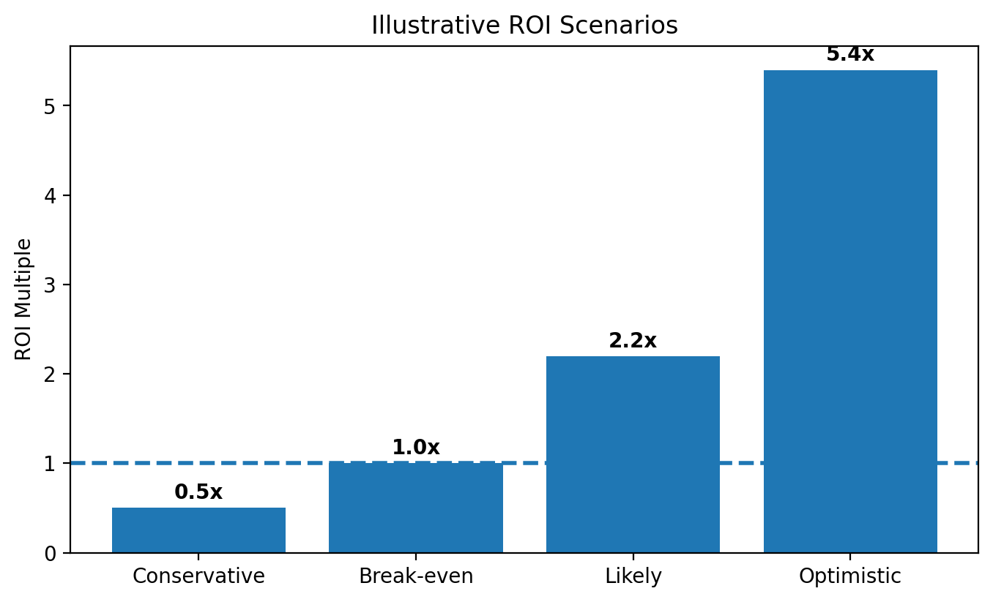

04 Patient Flow Funnel
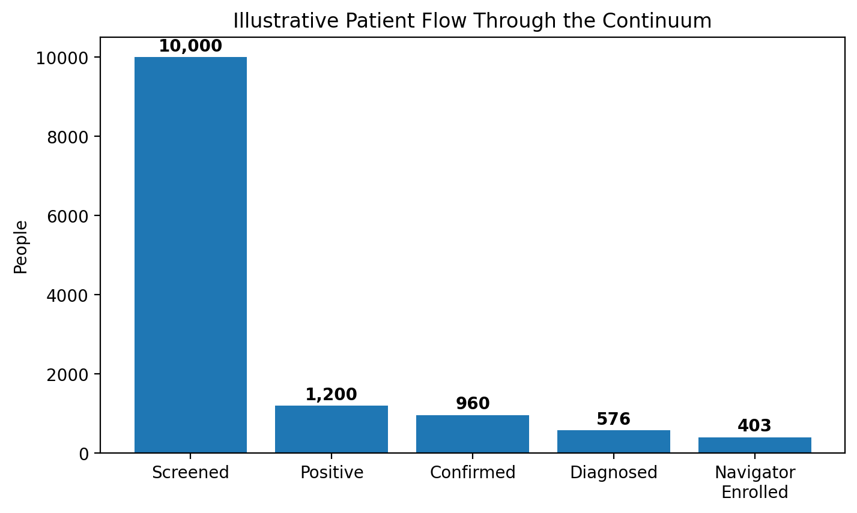

05 Cost of Delay Index
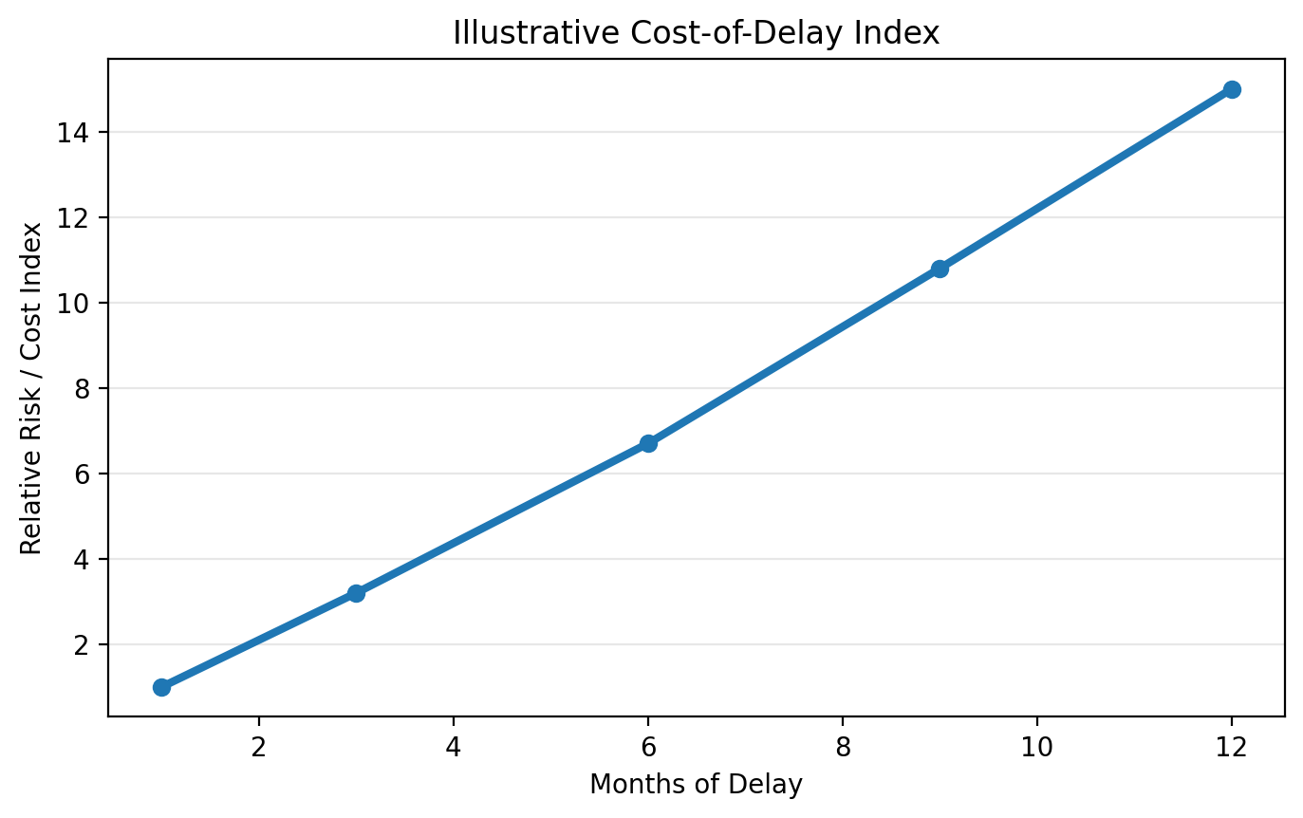

06 Caregiver Value Pie
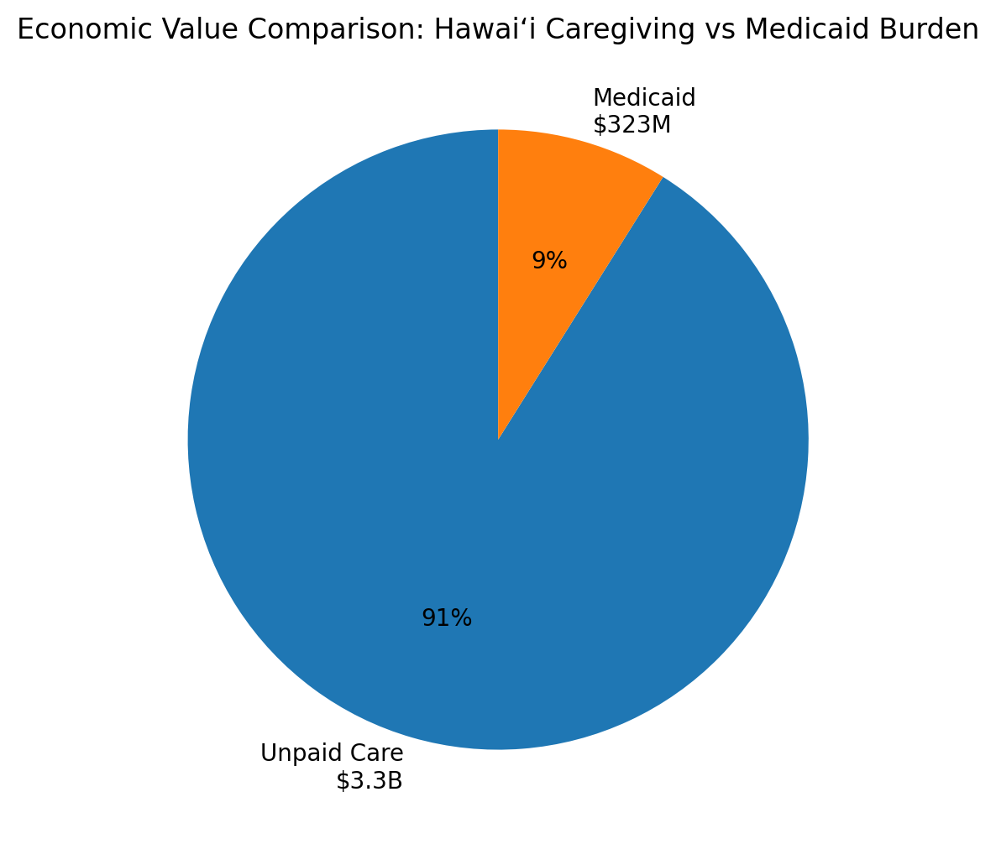

07 ASAP AADAPT HANAI Flowchart
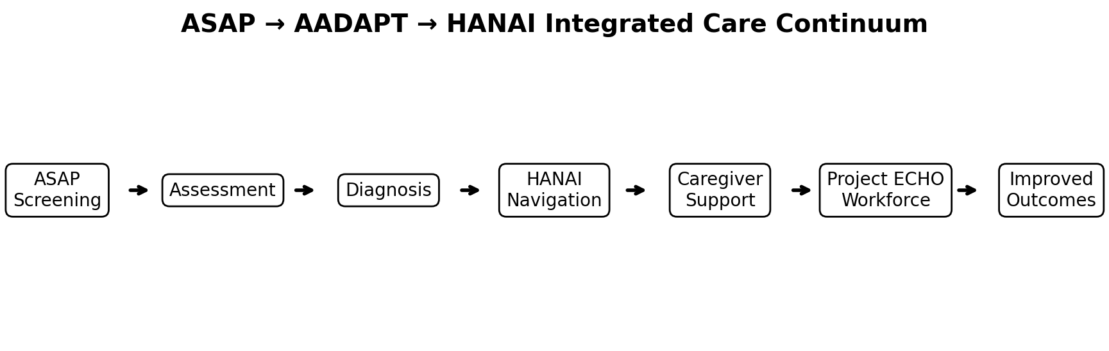

08 Project ECHO Hub and Spoke
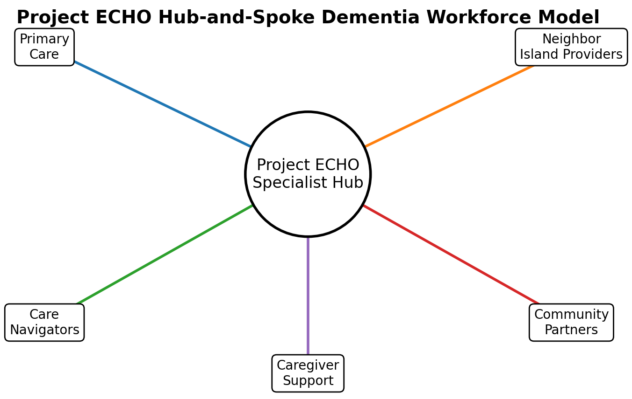

09 Break Even Callout
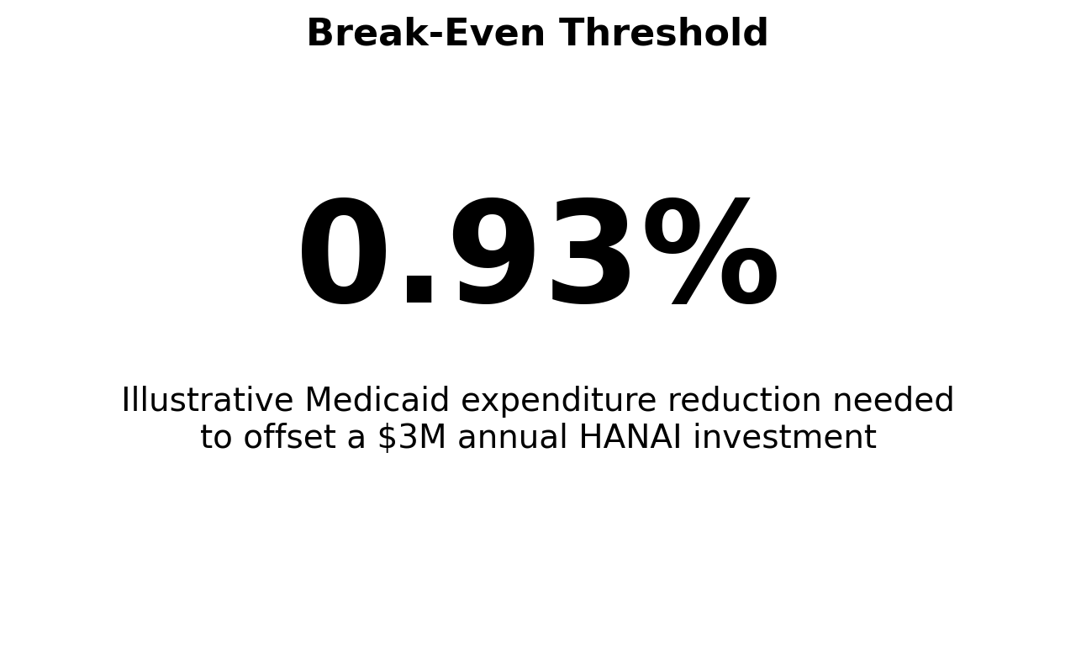

10 Five Year Implementation Roadmap
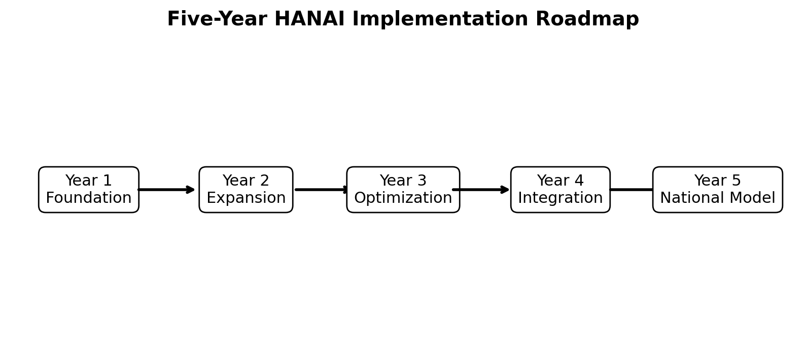

11 KPI Dashboard Mockup
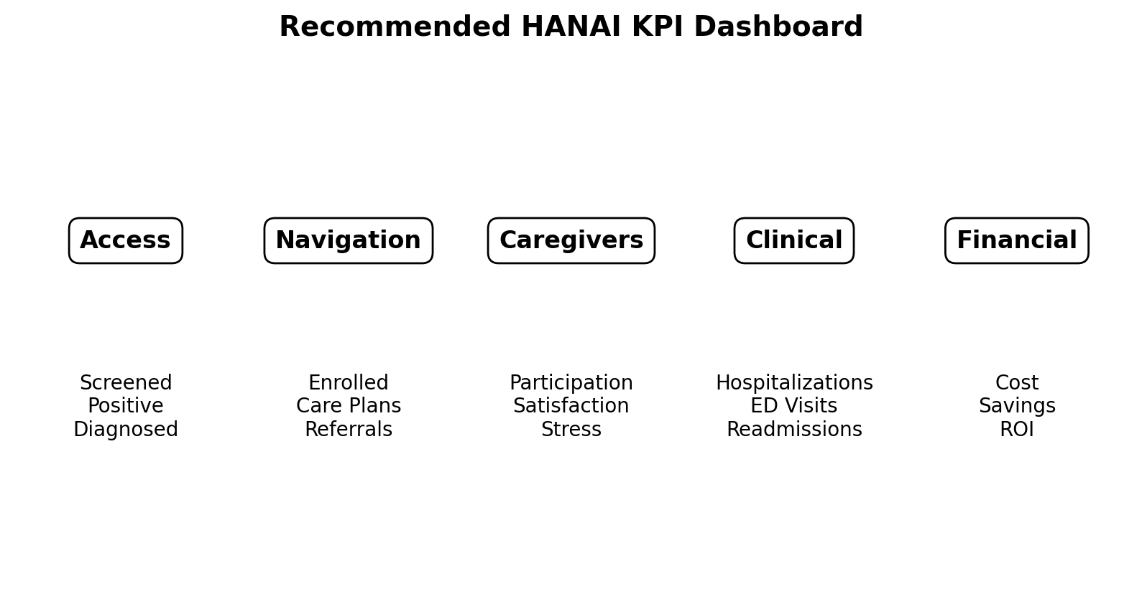

12 Continuous Improvement Cycle
