Building America’s Alzheimer’s Continuum of Care
A Hawaiʻi model for earlier diagnosis and lasting family support
Policy framework and an illustrated family story

Written by Girard “Jerry” Perone
Alzheimer’s advocate in Hawaiʻi
Original report May 30, 2026
Edited September 21, 2026
This document has not been reviewed or approved by the Alzheimer’s Association. It is an advocacy and policy-design document, not medical advice.
COPYRIGHT WARNING: This report is protected by U.S. and international copyright law. Copyright © 2026 Girard “Jerry” Perone. All rights reserved. No part of this document may be reproduced, distributed, stored in a retrieval system, transmitted, posted, copied, summarized, adapted, or used in whole or in part, in any form or by any means, without the prior written permission of the copyright owner, except as permitted by applicable law.

About the Author
Girard “Jerry” Perone is an Alzheimer’s advocate, public-policy researcher, and former IBM quality assurance executive. At IBM, his work in Financial Services Sector Strategic Outsourcing covered a portfolio of approximately $9 billion. He is the founder and president of National Management Center, Inc.
Jerry’s career has centered on making complex systems work. He has developed program plans, identified gaps in fragmented operations, and established clear measures of accountability. He holds a bachelor’s degree in electrical engineering and an MBA in finance and accounting, and has consulted in more than 60 countries.
Through his work as an Alzheimer’s Association Ambassador in Hawaiʻi, Jerry has advocated for earlier detection, caregiver support, workforce training, and coordinated memory care. His writing includes policy reports, newspaper articles, legislative testimony, and practical materials for advocates.
This report brings that experience to a question families face every day: after someone notices a memory problem, who helps them take the next step? Part I proposes a coordinated response. Part II follows a fictional family to show what that response could mean at home.

Contents
About the Author 2
Part I Building the continuum 5
1 Executive summary 5
2 The crisis and the opportunity 6
3 Why demonstrate the model in Hawaiʻi 7
4 How a family moves through care 8
5 Blood tests and treatment options 10
6 ASAP and access to earlier detection 11
7 AADAPT and workforce preparation 12
8 Project ECHO and shared clinical expertise 14
9 GUIDE and practical family support 15
10 What HANAI must do for families 16
11 Technology that supports everyday care 18
12 Measuring results and assigning responsibility 19
13 Adapting the Hawaiʻi model elsewhere 21
14 Costs and illustrative financial scenarios 23
15 Preparing for future scientific advances 25
16 Decisions and actions requested 27

Contents continued
Part II The story of Hawaiʻi’s continuum of hope 28
Prologue The morning the ocean looked different 28
Chapter 1 The old system had a sound 29
Chapter 2 Hawaiʻi chooses a different path 30
Chapter 3 The call that changed the room 31
Chapter 4 The appointment that almost failed 32
Chapter 5 A blood draw and more questions 32
Chapter 6 The result that needed a team 33
Chapter 7 Knowledge crosses the ocean 33
Chapter 8 Mālama becomes a plan 34
Chapter 9 The night the system was tested 35
Chapter 10 The Capitol and the canoe 36
Chapter 11 What the dashboard revealed 37
Chapter 12 Sharing the model beyond Hawaiʻi 37
Chapter 13 The 2050 letter 38
Epilogue Hope in daily practice 39
Actions readers can take 39
Closing blessing 41
Glossary 42
Acronym Dictionary 48
Source Notes 52
Contact and Additional Information 54

Part I Building the continuum
Hawaiʻi can build a connected dementia-care system that helps families from the first memory concern through evaluation, care planning, and ongoing support. This report proposes how federal initiatives and Hawaiʻi’s memory network could work together, with clear responsibilities and measurable results.
The test is practical: does the family know what happens next, who will help, and whom to call when something changes? The recommendations below are intended for policymakers, health systems, clinicians, and community partners responsible for making that path reliable.
Scope of this edition. This is an editorial revision of the May 2026 policy framework, with selected clinical and program clarifications. It is not a comprehensive update of legislative status, appropriations, or local service availability. Consult the linked bill and agency records before using it as a current implementation brief.

1 Executive summary
A family often notices the problem long before it knows where to turn. Bills go unpaid. Medication becomes confusing. A spouse begins sleeping lightly, listening for the front door. By the time help arrives, the family may already be in crisis. Earlier evaluation and dependable follow-up can give people more time to plan and help caregivers manage what lies ahead.
The scale is substantial. The Alzheimer’s Association’s 2026 report estimates that more than 7 million Americans are living with Alzheimer’s disease and nearly 13 million people provide unpaid dementia care. Health and long-term-care spending is projected to reach $409 billion in 2026 and nearly $1 trillion in 2050. The spending estimate excludes the value of unpaid caregiving. Behind those totals are families managing appointments, work, household costs, and increasingly difficult decisions. [1]
I propose a Hawaiʻi demonstration that connects the ASAP and AADAPT legislative proposals, Project ECHO training, the CMS GUIDE Model, and the HANAI Memory Network. Appropriate diagnostic testing, treatment assessment, and technology would support that work. Each part should lead to a completed next step for the family.
The design places the person and ʻohana at the center. It asks public agencies, clinicians, and community organizations to share responsibility for the handoffs that families currently have to manage themselves.
The immediate aim is to help people receive a timely evaluation, a usable care plan, and ongoing support. The longer-term aim is to build a system ready to deliver better treatments and prevention strategies as the evidence develops.
A family should leave each encounter knowing the next step and the person responsible for helping it happen.
Reading the framework. ASAP and AADAPT are legislative proposals; GUIDE is a federal demonstration with eligibility rules. HANAI operating arrangements in this report are recommendations. The service targets and financial scenarios are planning assumptions, and Part II is fiction.
Component | What It Does | Why It Matters in Hawaiʻi
ASAP Act | Proposes a Medicare coverage pathway for blood-based Alzheimer’s screening tests, subject to applicable requirements. | Opens the front door earlier, especially where PET scans, specialty visits, or spinal fluid testing are difficult to access.
AADAPT Act | Would support provider participation in structured virtual dementia education and case-based training. | Builds the workforce that must act once earlier detection increases demand.
Hawaiʻi training recommendations | Build practical dementia skills for clinicians and community-facing staff. | Creates local capacity, reduces missed recognition, and makes “no wrong door” more realistic.
Project ECHO | Uses virtual specialist mentoring and real de-identified cases to support community providers. | Moves knowledge across the ocean instead of forcing every patient to travel.
CMS GUIDE Model | Supports care navigation, caregiver support, care planning, respite where eligible, and 24/7 access. | Turns diagnosis into practical help for families.
HANAI Memory Network | Provides a state framework; the report proposes how services, referrals, and data should connect. | Makes the continuum real for Oʻahu, Maui, Kauaʻi, Hawaiʻi Island, Molokaʻi, and Lānaʻi.
Technology Layer | Uses telehealth, medication tools, remote monitoring, caregiver communication, and FHIR-ready data. | Helps connect services across islands and supports follow-up.

2 The crisis and the opportunity
America already spends heavily on dementia care. Too much help arrives after a problem has become an emergency. Medication confusion may contribute to a fall; an exhausted caregiver may have no choice but to seek urgent placement. Earlier planning cannot prevent every crisis, but it can address risks before they become harder to manage.
Alzheimer’s disease is the most common cause of dementia. Dementia describes a decline in memory, thinking, or other abilities severe enough to interfere with daily life. Families experience it through repeated questions, missed bills, driving worries, disrupted sleep, and changes in familiar routines. Caregivers often carry these concerns while trying to keep the rest of life going.
Several developments make a more coordinated approach possible. Blood-based diagnostic aids can support evaluation in appropriate patients. Provider training and care-navigation models offer ways to strengthen care. Telehealth can reduce some travel burdens. The task now is to connect these tools to local services that families can actually reach.
The long-term aspiration is a world without dementias. Today’s responsibility is to improve care with the evidence and services available, while supporting research that may change what is possible.
Crisis Pattern | Typical Result Today | Continuum Response
Memory concern is minimized | Family waits until symptoms are obvious and risk is higher. | Screen and evaluate earlier; normalize cognitive conversations.
Provider lacks dementia support | Referral delays or uncertain next steps. | AADAPT + ECHO strengthen primary care and community providers.
Diagnosis occurs without navigation | Family receives a label but no operating plan. | GUIDE + HANAI assign a navigator and written care plan.
Caregiver burden is invisible | Burnout, missed work, health decline, or premature placement. | Assess caregiver strain and connect respite, education, and support.
No closed-loop referral tracking | Services are “recommended” but never completed. | Dashboard referral closure and follow-up.
Technology is added without purpose | More devices, not more care. | Use technology only where it reduces risk, travel, delay, or burden.

3 Why demonstrate the model in Hawaiʻi
Hawaiʻi offers a demanding setting in which to test coordinated dementia care. Urban Honolulu, rural communities, and neighbor islands have different needs and resources. Cultural and language differences also shape how families seek help. A model that works across those settings could offer useful lessons to other states.
For a neighbor-island family, a specialist appointment may mean airfare, time off work, and help arranging travel for someone who finds unfamiliar places distressing. Oʻahu’s greater concentration of specialists does not automatically translate into access elsewhere. The design must account for that distance.
HANAI can provide a shared route into care: a place for families to ask for help, a referral pathway for providers, and a way for public agencies to follow progress. Its value will depend on whether those connections work in daily practice.
Community organizations and families should help shape the service from the start. Language access, trusted local relationships, and respect for the person’s preferences need to be reflected in staffing and care planning.
Hawaiʻi Challenge | Why It Matters | Design Response
Island geography | Specialty care cannot be concentrated only in one place. | Tele-HANAI hub, county access points, ECHO mentoring, and hybrid clinic capacity.
Neighbor-island access gaps | Diagnosis and treatment pathways can be delayed or unavailable. | County dementia care specialists and contracted memory clinics.
Workforce limitations | Every new screening pathway increases demand on clinicians. | AADAPT, state training, Project ECHO, and role-based protocols.
Cultural diversity | One-size-fits-all messaging may fail families. | Community partners, language access, cultural humility, and ʻohana-centered planning.
High caregiver burden | Family caregiving is the backbone of the system but can collapse. | Caregiver assessment, respite linkage, education, and 24/7 support pathways.
Data fragmentation | No one can manage what no one can see. | Minimum data dictionary, dashboard governance, and FHIR-ready design.

4 How a family moves through care
The continuum connects recognition of a concern with evaluation, a care plan, and continuing support. Provider training and measurement support every stage. Families may enter at different points, and their needs may require them to return to an earlier step.
A directory gives a caregiver a list of services. A working continuum also identifies who will arrange the next step and check that it happened. That follow-through is especially important when a referral involves travel, cost, or a long wait.
Families should be able to enter through primary care, a community organization, an aging-services agency, a caregiver helpline, or a hospital discharge. Each entry point needs clear routing instructions and an urgent-care pathway for immediate safety concerns.
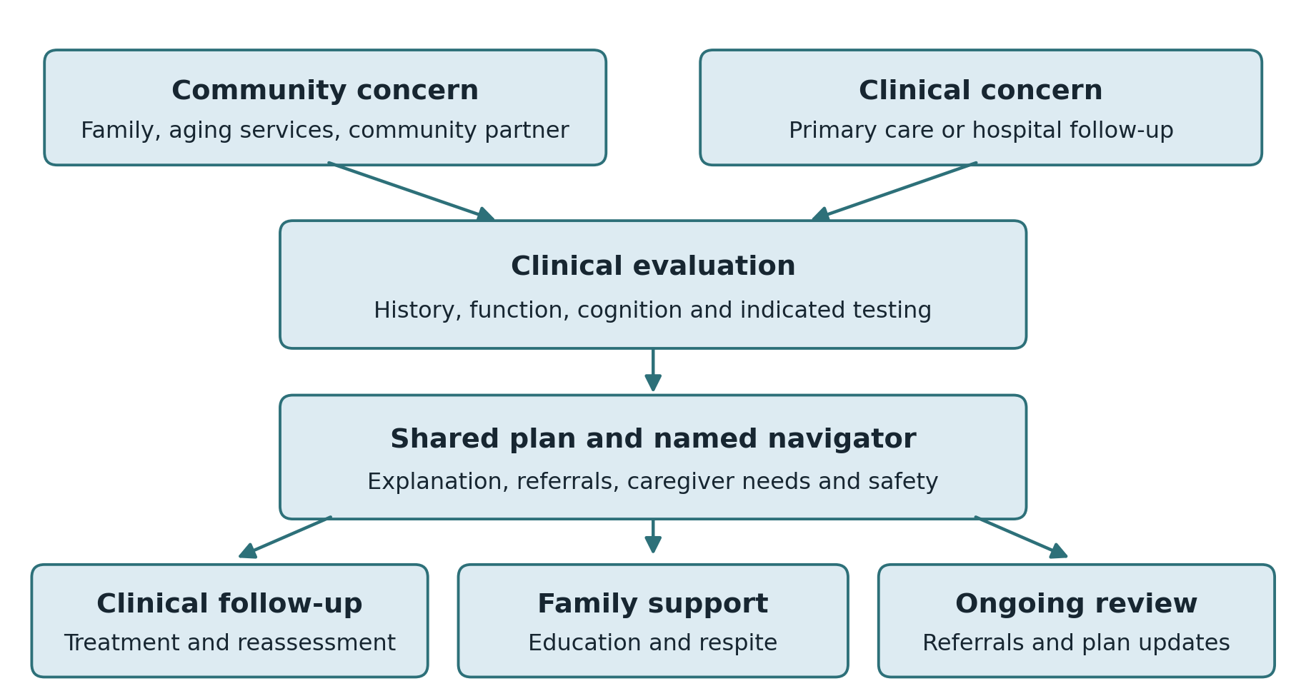
Proposed care pathway. Evaluation may identify another cause of symptoms. Support begins when needed; no blood test is required for every person. Urgent medical concerns require immediate clinical triage.
Stage | Question Answered | Lead Tool | Data Output
Notice | Who is worried and why? | Family, PCP, community partner, ADRC, health plan | Concern type, urgency, caregiver contact, safety flags
Screen | Who may need further evaluation? | Clinical assessment and cognitive tools; blood tests only when indicated | Screen date, test type, result, referral trigger
Train | Can the local front door respond? | AADAPT + Hawaiʻi training + Project ECHO | Training completion, confidence gain, case participation
Evaluate | What does the result mean clinically? | Primary care, memory clinic, neurology/geriatrics | Diagnostic workup, staging, differential diagnosis, treatment eligibility
Navigate | Who helps the family now? | CMS GUIDE + HANAI navigator/DCS | Navigator assignment, caregiver assessment, care plan status
Support | What reduces risk and burden? | HANAI + ADRC + community partners | Respite, coaching, safety plan, legal/financial planning referrals
Monitor | How do we keep the plan alive? | Telehealth, medication tools, remote monitoring, scheduled check-ins | Adherence, alerts, status changes, follow-up completion
Measure | Did outcomes improve? | HANAI dashboard + FHIR-ready data | Wait time, ER use, hospitalization, referral closure, satisfaction, cost
These responsibilities are connected. Testing requires interpretation and follow-up. Training requires somewhere to refer patients. Navigation requires available services. Technology requires someone to respond. The operating plan must specify how each handoff will work.

5 Blood tests and treatment options
Blood-based tests can help clinicians evaluate Alzheimer’s disease in appropriate patients. The FDA cleared the Lumipulse G pTau217/β-Amyloid 1-42 Plasma Ratio test in May 2025 for adults aged 55 and older with signs and symptoms of the disease. It helps identify amyloid pathology and may reduce the need for other testing in some patients. It is a diagnostic aid, not a diagnosis by itself. [2]
That specific test is not intended for general screening of people without symptoms. Clinicians must interpret results alongside the history, cognitive assessment, daily functioning, and other possible causes of difficulty. Appropriate evaluation may also include medication review, laboratory testing, or imaging. A result needs an explanation and a clear next step.
Leqembi and Kisunla are examples of FDA-approved treatments that target amyloid. They can slow decline in selected people with early symptomatic Alzheimer’s disease; they do not cure it. Treatment requires confirmation of amyloid pathology, careful eligibility review, and safety monitoring. Brain swelling and bleeding are important risks to discuss, along with the likely benefit, costs, and burden of treatment. [3, 4]
Earlier clarity gives families time to discuss treatment, make practical plans, and seek support. That time matters even when a person is not eligible for a particular medicine.
Scientific Advance | What It Changes | System Requirement
Blood-based diagnostic aids | May reduce barriers to identifying Alzheimer’s pathology in symptomatic people who need evaluation. | Coverage, clinician training, result interpretation, follow-up capacity, and equity safeguards.
Disease-modifying therapies | Create a reason for earlier diagnosis because some options are stage-dependent. | Eligibility protocols, MRI monitoring, infusion/injection capacity, risk counseling, and referral criteria.
Biomarker staging | Moves the field toward more precise classification of disease biology. | Careful communication so biomarkers do not become frightening labels without support.
Prevention science | Highlights risk reduction, brain health, and possible future pre-symptomatic interventions. | Public-health campaigns, primary-care workflows, and inclusive research enrollment.
Digital biomarkers | May detect change in speech, gait, sleep, activity, or daily patterns earlier. | Privacy, consent, validation, and integration into clinical care rather than surveillance.

6 ASAP and access to earlier detection
The Alzheimer’s Screening and Prevention Act, or ASAP Act, proposes a Medicare coverage pathway for blood-based Alzheimer’s screening tests. Its policy goal should be distinguished from the approved uses of individual tests: a coverage proposal does not make every test appropriate for every patient. Clinical use must follow the relevant evidence, FDA labeling, and coverage requirements. [5]
A concerning result should lead to clinical evaluation, an explanation of what is known, and help arranging follow-up. A testing program should be judged partly by what happens after the result arrives.
In Hawaiʻi, blood collection may be easier to arrange locally than specialty imaging. Primary care practices, federally qualified health centers, and rural clinics could help expand access if they have trained staff and reliable referral pathways. Coverage and follow-up capacity need to develop together.
ASAP Workflow Step | Operational Detail | HANAI Link
Eligibility check | Use coverage rules, clinical indication, symptoms, age, and medical context. | Avoid inappropriate testing and prevent false reassurance or unnecessary alarm.
Blood-based test | Order FDA-approved or FDA-cleared test when clinically appropriate. | Make the front door less dependent on PET scan access or lumbar puncture.
Result interpretation | Explain that the test is an aid, not a stand-alone diagnosis. | Use trained clinician or ECHO-supported workflow.
Diagnostic follow-up | Complete cognitive, clinical, functional, and differential workup. | Refer to memory clinic or specialty pathway when needed.
Care-plan activation | Assign navigator/DCS and initiate caregiver assessment. | Convert a result into practical next steps.
Dashboard tracking | Track positive follow-up, time to evaluation, and referral closure. | Prevent screening from becoming a one-time event.

ASAP KPI | Formula | Why It Matters
Appropriate testing rate | Clinically eligible people tested / clinically eligible people offered testing | Measures reach.
Positive Follow-Up Rate | Positive or concerning screens with diagnostic follow-up / positive or concerning screens | Prevents screening dead ends.
Time to Diagnostic Evaluation | Median days from concerning screen to diagnostic evaluation | Measures access speed.
Early-Stage Diagnosis Share | Early-stage diagnoses / total diagnoses | Shows whether detection is moving earlier.
Referral-to-HANAI Rate | Patients referred to HANAI / patients with qualifying diagnosis | Connects federal screening to state support.

7 AADAPT and workforce preparation
Earlier detection creates more demand for evaluation and support. The AADAPT Act proposes grants that support provider participation in structured virtual dementia education. The aim is to help primary care and community clinicians recognize concerns, assess patients, and arrange appropriate care. [6]
Hawaiʻi also needs practical training for the people who first hear a family’s concerns. Clinicians and community staff should know how to recognize a possible problem, discuss it respectfully, and connect the family with the right service.
Primary care clinicians need enough support to manage appropriate cases locally and recognize when specialist input is needed. Training should include medication safety, caregiver needs, and reliable follow-up.
Training should match the job. A physician needs diagnostic guidance. Nurses need clear medication-review and safety procedures. Social workers need tools for assessing caregiver strain and arranging services. Community and intake staff need to know which concerns require prompt escalation.
Training Function | Federal / State Tool | Hawaiʻi Implementation Logic
Basic recognition | State dementia training + AADAPT | Help clinicians and community-facing staff identify red flags earlier.
Diagnostic pathway | AADAPT + Project ECHO | Support appropriate use of cognitive tools, blood tests, imaging, medication review, and referrals.
Care planning | GUIDE + HANAI | Convert diagnosis into family instructions and next steps.
Cultural competence | HANAI + community partners | Include families, language access, local partners, and culturally appropriate communication.
Crisis prevention | ECHO + GUIDE + DCS protocols | Teach fall risk, wandering risk, delirium risk, medication safety, and caregiver burnout prevention.
Continuing improvement | ECHO + dashboard | Use cases and data to improve training over time.

Provider Group | Minimum Competency | Practical Test of Success
Primary care clinicians | Recognize impairment, start workup, order appropriate tests, refer correctly. | A concerning result leads to a completed diagnostic pathway, not a delayed referral.
Nurses and medical assistants | Medication review, safety flags, functional questions, caregiver identification. | Medication confusion and safety risks are identified before crisis.
Social workers / DCS staff | Caregiver assessment, benefits navigation, LTSS linkage, closed-loop referrals. | Caregiver receives a named plan and completed service linkage.
Community partners | Stigma reduction, no-wrong-door routing, family preparation. | Families know what to document before the first appointment.
Specialists | ECHO mentorship, complex case consultation, treatment eligibility support. | Specialty knowledge reaches neighbor-island providers without unnecessary travel.

8 Project ECHO and shared clinical expertise
Project ECHO connects community providers with specialist teams through virtual teaching and discussion of de-identified cases. Providers bring practical questions, learn from one another, and apply that knowledge in their own communities.
For Hawaiʻi, this can reduce professional isolation and help local clinicians address questions that might otherwise require a specialist visit. Some patients will still need to travel, but routine access to expert advice can make local care more capable.
HANAI should use continuing case discussion to support providers after their initial training. Dementia care raises questions about behavior, safety, family relationships, and access to services as well as diagnosis and treatment. An ongoing learning network gives providers a place to work through those questions.
ECHO Component | Plain-Language Meaning | Dementia Application
Hub Team | Specialists and expert faculty | Neurology, geriatrics, psychiatry, pharmacy, social work, care navigation, public health.
Spokes | Community providers | PCPs, FQHCs, rural clinics, neighbor-island clinicians, health-plan teams, DCS staff.
Case-Based Learning | Real de-identified cases | Memory loss, wandering, caregiver crisis, medication risk, treatment eligibility, rapid decline.
Brief Didactics | Short expert teaching segments | Blood-test interpretation, staging, differential diagnosis, safety planning, caregiver support.
All Teach, All Learn | Peers and experts learn together | Builds confidence, not dependency.
Data Feedback | Use dashboard trends as learning material | If one island has slower follow-up, the ECHO curriculum can respond.
A useful ECHO session should leave the provider with a clearer next step for the patient. That might be a medication review, a safety plan, a social-work referral, or an urgent specialist assessment. The benefit should be visible in the care that follows.

9 GUIDE and practical family support
After a diagnosis, families need help carrying out a plan. The CMS GUIDE Model tests a payment and service approach that includes dementia care coordination, caregiver education, a support line available around the clock, and respite for eligible participants. Access depends on beneficiary eligibility and a participating provider. [7]
HANAI could coordinate with participating GUIDE providers where available and draw on its service principles for other families. The proposed pathway links evaluation with navigator contact, caregiver assessment, a written plan, and follow-up. Families should understand which services they qualify for and who will provide them.
GUIDE offers an established federal model to learn from. It does not automatically fund all HANAI services or enroll every person with dementia. Hawaiʻi’s implementation plan must identify how services outside GUIDE eligibility will be staffed and paid for.
GUIDE Function | HANAI Translation | Recommended KPI
Care Navigation | Navigator or DCS assigned after diagnosis or qualifying concern. | Navigator contact within 30 days.
Care Plan | Documented dementia care plan shared with family and clinical team. | Care plan completion rate.
Caregiver Support | Education, coaching, assessment, respite linkage where eligible. | Caregiver assessment and support rate.
24/7 Access | Urgent guidance or escalation pathway. | After-hours response tracking.
Community Linkage | Clinical and community referrals with closure tracking. | Referral closure rate.
Home-and-community focus | Support safety at home and delay avoidable institutionalization. | Home time, caregiver strain, ED use, and hospitalization trends.
Care plans should be easy for families to use. With appropriate permissions, service and claims data can also help evaluators assess whether navigation improves outcomes or changes costs. Supporting a caregiver has value in its own right; any financial benefit should be measured separately.

10 What HANAI must do for families
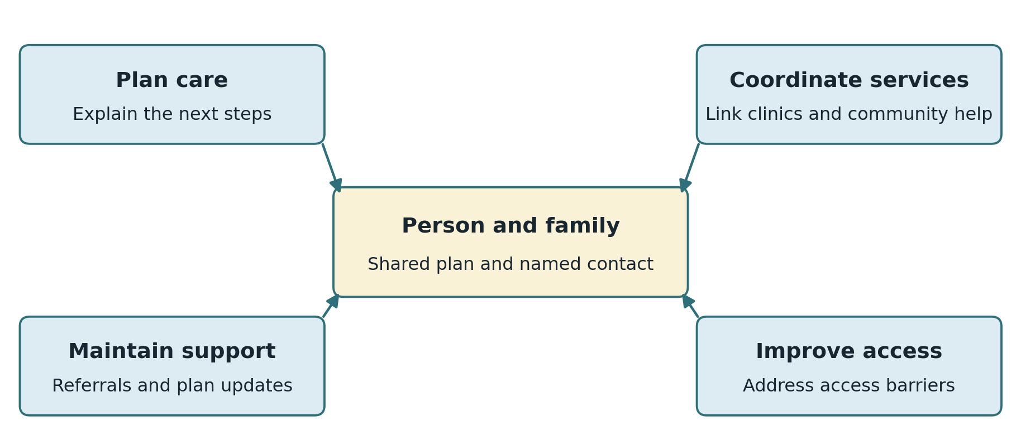
HANAI’s proposed responsibilities connect a shared care plan with local services and continuing follow-up.
Federal initiatives can support testing, training, and care coordination. Families still need a local service that answers their questions and stays involved. This report proposes HANAI as the structure that connects those resources in Hawaiʻi.
HANAI would help develop the care plan, keep it current, and coordinate services as needs change. It should also address access barriers across islands. For a family, the result should be straightforward: someone knows their situation and helps them follow through.
The Hawaiian word hānai conveys nurturing and care. That idea should be reflected in the way people are welcomed, listened to, and included in decisions.
The proposed operating structure has three parts: an entry point coordinated with the Executive Office on Aging and aging-services agencies; clinical capacity through memory clinics and primary care partners; and continuing support from dementia care specialists, navigators, and community organizations. Shared information and agreed referral procedures would connect them.
Original HANAI concept. The supplied 2025 infographic proposes one dementia care specialist in each county and one contracted memory clinic in each neighbor-island county, coordinated through the Executive Office on Aging. Each clinic would include at least one MD, DO, or APRN, one RN, and one licensed social worker. These are source-concept staffing assumptions, not a verified description of current operations. [8]
HANAI Design Principle | Operational Meaning | Concrete Example
Statewide access | No island should be left without a practical pathway. | County DCS + contracted clinic capacity + telehealth support.
Use existing assets first | Build on EOA, DOH, health systems, FQHCs, ADRCs, Area Agencies on Aging, and community partners. | Contract capacity instead of building every clinic from zero.
Telehealth by default where appropriate | Reduce travel burden for neighbor-island families. | Remote intake, caregiver coaching, results discussion, medication follow-up.
In-person when necessary | Do not overuse technology for complex diagnoses or unsafe situations. | Rapid decline, focal neurologic signs, severe behavioral symptoms, treatment eligibility workup.
Closed-loop referrals | Track whether referrals were completed, not merely made. | Referral closure rate by island and provider group.
Culturally grounded care | Involve families and trusted partners; respect language and care preferences. | Family-inclusive care planning and community-language outreach.
Dashboard governance | Use common definitions, monthly reporting, and transparent performance review. | Island-specific wait times and outcome trends.

HANAI Lifecycle Step | Primary Owner | What the Family Experiences
Intake and triage | EOA/ADRC or HANAI front door | Someone listens, records concerns, and explains the next step.
Pre-visit preparation | DCS / navigator | Records, medication lists, caregiver observations, and safety flags are gathered.
Clinical evaluation | Memory clinic / trained provider | The person is evaluated as a whole person, not reduced to a score.
Care plan | Clinical team + DCS | The family receives written instructions and named supports.
Service linkage | DCS / ADRC / community partner | Referrals are followed until completed or replaced with another plan.
Maintenance | HANAI team | Follow-up occurs before crisis, not only after crisis.
Escalation | Navigator + clinical partner | Urgent changes have a pathway other than the emergency room.
Learning loop | HANAI dashboard governance | Data from many families improves the system for the next family.

11 Technology that supports everyday care
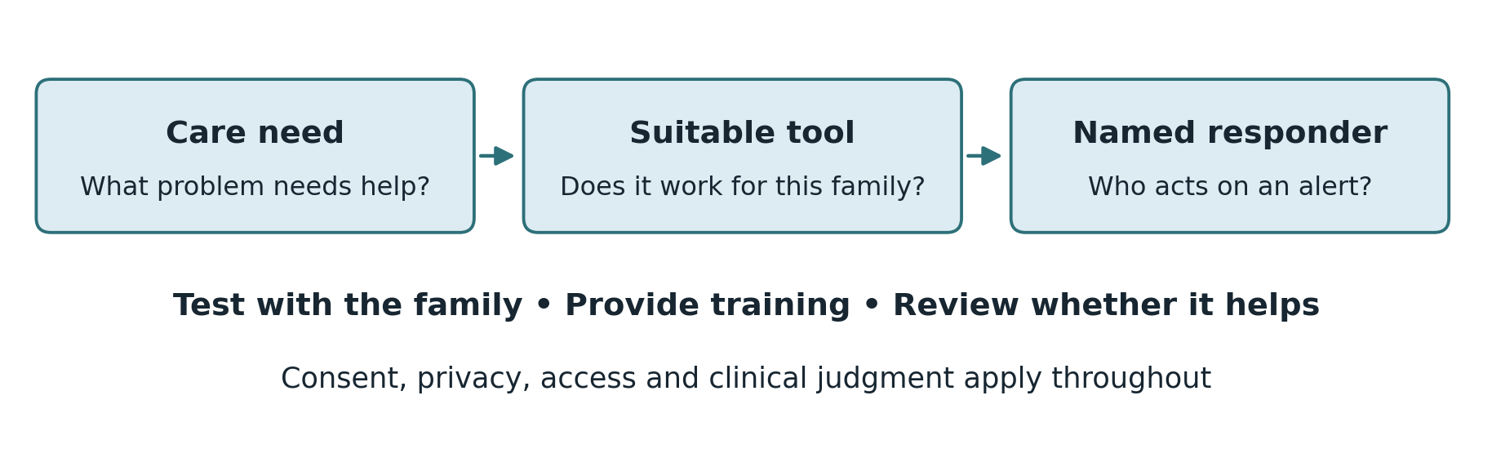
A tool is useful only when it addresses a care need and someone is responsible for responding.
Technology can help families stay connected to care. Video visits may reduce travel. Medication tools can support an agreed dosing plan. Some wearables and sensors can alert caregivers to possible falls or other changes. Capabilities and reliability vary, so each tool needs to be chosen for a specific need and tested with the family.
Begin with the care plan. If medication confusion is the problem, first review the medicines and responsibilities; a dispenser may then help. If nighttime wandering is a concern, a door alert may be one part of a broader safety plan. A family also needs setup help, training, and a clear response when an alert arrives.
Care and referral data can help the network identify delays and unmet needs. Collect only information needed for care or evaluation, explain how it will be used, and define who may access it. Families should have a way to correct errors and raise concerns.
FHIR is a standard for exchanging health information. A pilot can start with a small shared data dictionary and later map it to electronic health records and other systems. Describing data as FHIR-ready is a design goal; actual exchange still requires technical work, agreements, and testing.
Technology Function | Use Case | Guardrail
Telehealth | Intake, follow-up, caregiver coaching, result review, remote specialist consultation. | Do not use when in-person exam or urgent evaluation is clinically necessary.
Medication tools | Reminders, dispensing support, adherence alerts, reconciliation prompts. | Avoid replacing caregiver communication with automation.
Wearables and sensors | Falls, activity change, sleep patterns, wandering risk, post-acute monitoring. | Use consent, privacy controls, and clear response rules.
Family communication | Video participation by off-island relatives, shared care-plan updates. | Respect the person’s preferences and decision-making rights.
AI-assisted triage | Summarize concerns, flag safety risks, route referrals, support documentation. | Human review required; never allow AI to make unsupported diagnosis or treatment decisions.
FHIR-ready integration | Map observations, care plans, referrals, and outcomes to interoperable data structures. | Start with a minimum data set and expand only when value is proven.

12 Measuring results and assigning responsibility
The pilot should measure whether families receive timely help and whether that help makes a difference. Results should be reported by island or county as well as statewide, so an average does not conceal a long wait in one community.
The executive dashboard should answer four questions: Can families get in? Do they receive an evaluation and a plan? Are caregivers supported? Are outcomes and costs improving? More detailed analysis can sit behind those measures.
Start with common definitions for referral dates, first contact, clinical evaluation, care-plan completion, caregiver assessment, and service follow-through. Add emergency visits, hospitalizations, and family experience where reliable data are available. The data can later be mapped to FHIR resources such as Observation, CarePlan, ServiceRequest, Condition, and Encounter.
The targets below are author recommendations for a pilot, not established service guarantees or measured results. The seven-day first-contact goal is distinct from the 30-day navigator-contact measure.
Domain | KPI | Definition | Proposed pilot target
Access | Referral-to-first-contact days | Median days from referral to navigator contact. | <= 7 days
Access | Referral-to-evaluation days | Median days from referral to first clinical evaluation. | 21–30 days
Clinical | Diagnostic follow-up | Positive/concerning screens with follow-up / positive/concerning screens. | 90%
Clinical | Early-stage diagnosis share | Early-stage diagnoses / total diagnoses. | Increase quarterly
Workforce | Training completion | Completed training / enrolled providers. | At least 85%
Navigation | Navigator contact | Contact within 30 days / assigned patients. | 95%
Navigation | Care plan completion | Completed care plans / assigned patients. | 90%
Referral | Referral closure | Closed referrals / referrals made. | 85%
Caregiver | Caregiver assessment | Caregivers assessed / identified caregivers. | 80%
Outcome | Emergency use | ED visits per 1,000 patient-months; assess avoidability separately. | Reduce over baseline
Outcome | Hospitalization rate | Admissions per 1,000 patient-months. | Reduce over baseline
Experience | Family satisfaction | Satisfied families / survey respondents. | At least 90%
Each measure needs an owner, a review schedule, and an agreed response when performance falls short. The Executive Office on Aging, clinical partners, community organizations, payers, and family representatives should have defined roles in that review.
Break-even reduction = annual program cost ÷ annual addressable baseline cost × 100%.
The financial test must use the same population and time period for costs and savings. Only spending the program could plausibly affect belongs in the addressable baseline. Earlier support may reduce some crisis use, but savings are not guaranteed and may accrue to a different payer from the one funding the program.

13 Adapting the Hawaiʻi model elsewhere
Hawaiʻi could provide other states with a tested operating model and practical materials for implementation. That requires collecting evidence from the beginning and documenting both what works and what needs to change.
Inter-island travel and uneven access to specialists make Hawaiʻi a useful setting for testing telehealth, shared clinical capacity, and navigation. Success here would offer lessons for other regions, though it would not prove that the same approach will work everywhere.
Other states face their own barriers, including long rural distances, provider shortages, fragmented urban services, and different Medicaid arrangements. Tribal communities also require approaches that respect sovereignty and local priorities. Each setting would need to adapt the model and test it locally.
Pilot-to-National Step | What Hawaiʻi Should Produce | How Other States Use It
1. Demonstrate | Launch HANAI with defined referral pathways, memory clinics, DCS roles, ECHO training, GUIDE alignment, and dashboard reporting. | Adopt the architecture while replacing island terms with county/region terms.
2. Measure | Publish monthly KPI trends: access, follow-up, care plans, caregiver support, ED use, hospitalizations, and family experience. | Use the same dashboard definitions to compare performance across states.
3. Package | Create implementation manuals, training modules, care-plan templates, data dictionary, sample contracts, and governance charters. | Reduce startup time and avoid reinventing the operating model.
4. Simplify | Document which Hawaiʻi-specific features are required only because of island geography. | Mainland states omit or simplify ocean-specific travel and tele-balancing complexity.
5. Adapt | Create archetype playbooks: rural/frontier, urban, tribal, border, Appalachian, and statewide managed-care models. | Each state adapts the same continuum to its population and delivery system.
6. Scale | Coordinate with CMS, CDC BOLD, ACL/aging networks, NIH research partners, and private plans. | Build a national dementia continuum learning collaborative.
Every adopting state should identify its entry points, clinical referral capacity, care-plan owners, caregiver supports, and evaluation responsibilities. The names of the programs may differ; the need for reliable follow-through will remain.
A federal replication package could include a program charter, sample contracts, training materials, care-plan templates, a data dictionary, and an implementation calendar. It should distinguish essential functions from features specific to Hawaiʻi.
Hawaiʻi Feature | Why It Is Hard in Hawaiʻi | Adaptation for other states
Inter-island distance | Families and clinicians may face flights, ferry gaps, and weather-related disruption. | Road access may help, although remote areas still face major travel barriers.
Specialty concentration on Oʻahu | Neighbor islands can wait or travel. | Use regional specialist and telehealth hubs where capacity exists.
Small island populations | Some clinics may have uneven utilization after backlog clears. | Larger catchment areas may sustain demand; staffing still needs local analysis.
Telehealth balancing | Kauaʻi, Maui, Hawaiʻi Island, Molokaʻi, and Lānaʻi may need shared capacity rules. | Regional sharing may help, depending on workforce, contracts, and travel distances.
Cultural and language diversity | The model must be culturally grounded and trust-based. | Every state still needs cultural adaptation, but can use the same design principle.
Ocean as a care barrier | The geography forces technology and care navigation to mature quickly. | Adapt the travel-reduction approach to local barriers.
Evaluation should include both service results and family experience. A shorter wait matters; so does whether the person understood the plan and the caregiver could carry it out.

14 Costs and illustrative financial scenarios
The Alzheimer’s Association projects national health and long-term-care spending of $409 billion in 2026 and nearly $1 trillion in 2050. These are broad spending estimates, not an estimate of what HANAI could save. The pilot’s financial case should focus on the costs and outcomes it can reasonably influence. [1]
The savings illustration uses a rounded $1 trillion annual spending baseline for 2050. A hypothetical 1% reduction in that total equals $10 billion; 5% equals $50 billion; 20% equals $200 billion. These are arithmetic scenarios before implementation costs, not forecasts. A 1% reduction in only the avoidable portion of spending would produce a smaller amount because the denominator would be smaller.
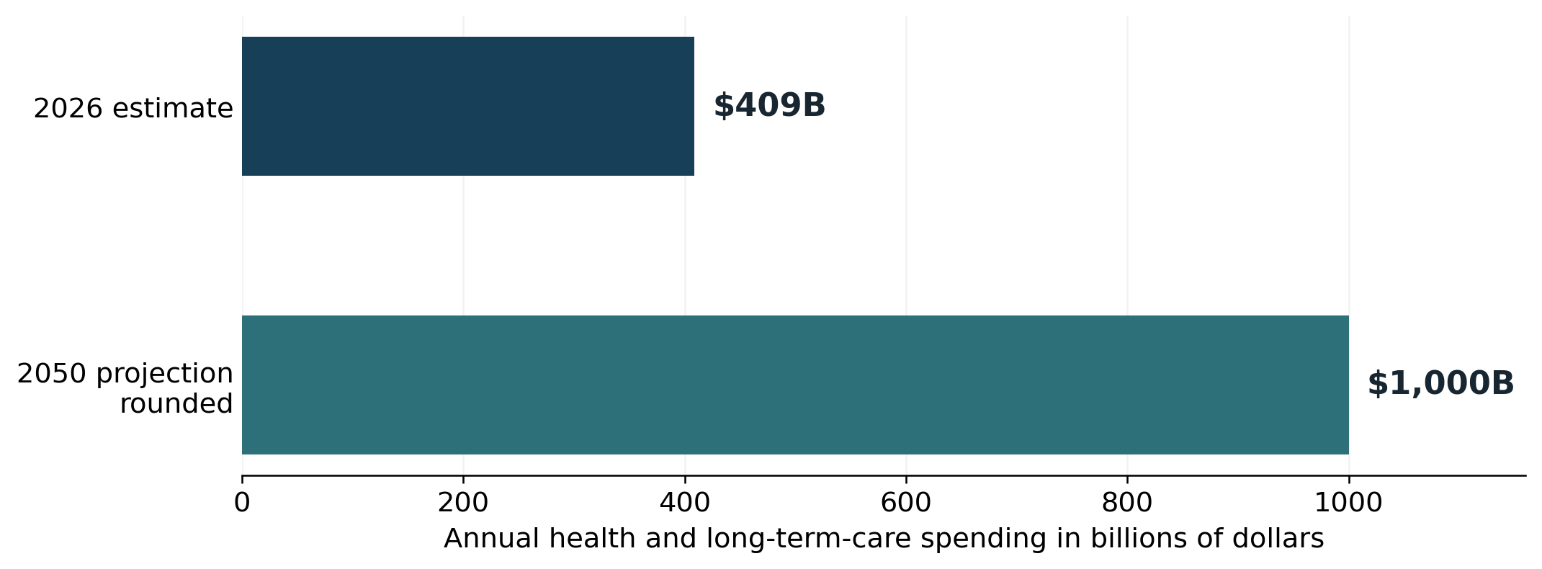
National spending anchors from the Alzheimer’s Association’s 2026 report. The 2050 value is rounded to $1 trillion. Intermediate years are not projected here. [1]
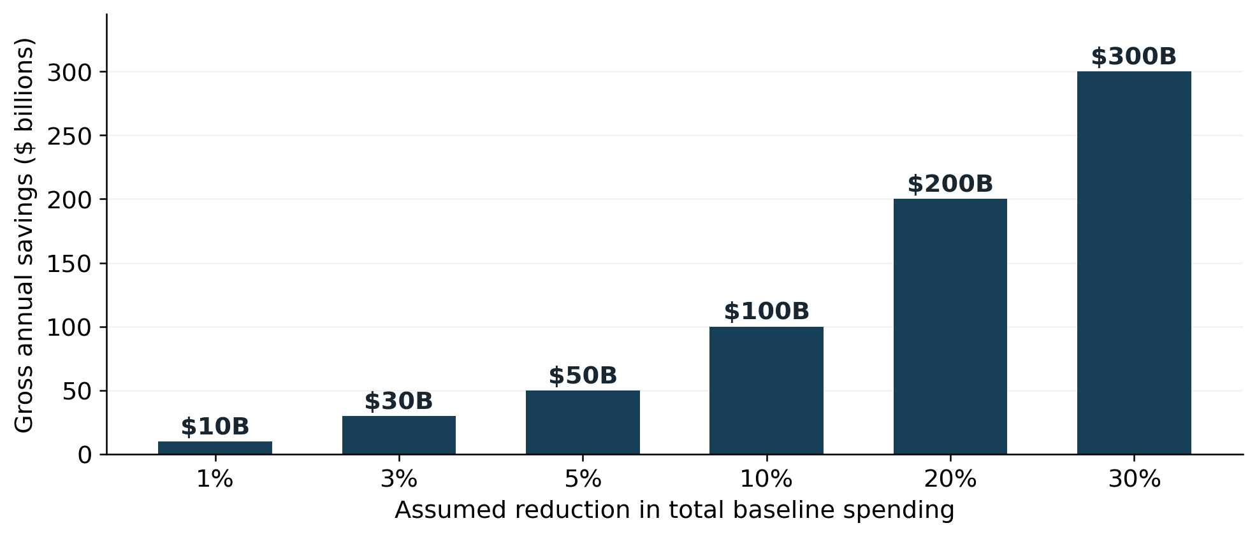
Illustrative gross annual savings against a rounded $1 trillion total spending baseline. Percentages are assumptions, not measured effects of the proposed continuum. Net savings would subtract program costs.
The supplied August 2025 HANAI concept uses a $3 million annual budget and identifies state appropriations and Medicaid reimbursement as intended funding sources. In this report, I treat that amount as a starting point for planning. Reimbursement eligibility, service volumes, staffing costs, and any later expansion require a separate operating budget. [8]
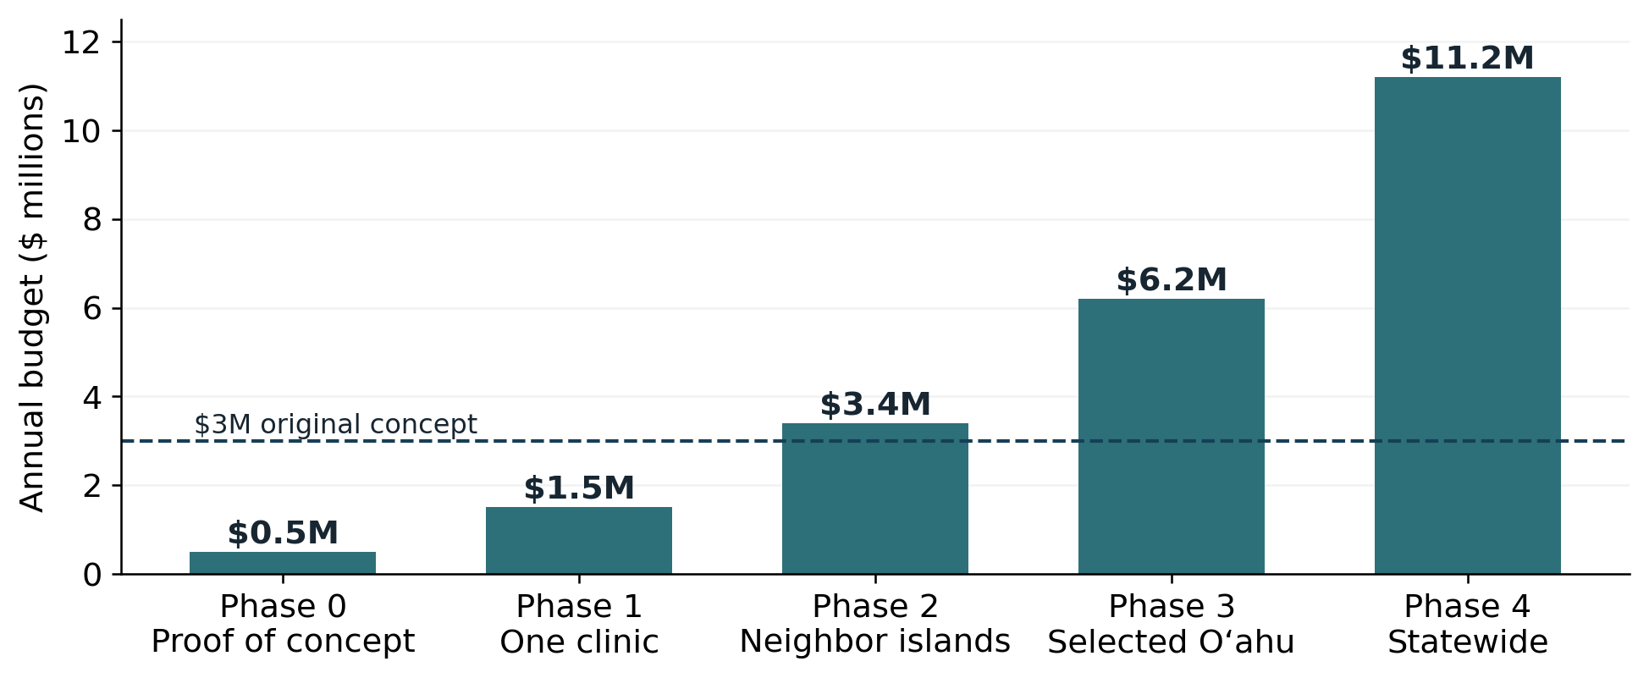
Planning scenarios retained from the original report: $0.5M, $1.5M, $3.4M, $6.2M, and $11.2M. These are illustrative annual budget levels, not approved appropriations or a validated cost estimate. The original report does not supply a staffing and utilization model supporting them.
Savings Lever | Possible financial effect | Human Benefit
Earlier diagnosis | May reduce some crisis-driven emergency and hospital use. | Families can plan before danger escalates.
Care navigation | May reduce duplication and missed follow-up. | Families have a named guide.
Caregiver support | May ease work disruption and pressure for crisis placement. | Caregivers are treated as part of the care unit.
Medication review | May reduce medication-related harm and associated visits. | The person is safer at home.
Telehealth follow-up | May reduce travel costs and missed follow-up. | Neighbor-island families receive care without repeated flights.
Safety monitoring | May support earlier response; savings depend on effectiveness. | Technology becomes a safety net, not surveillance.
Risk reduction and prevention | Delayed onset could reduce future care demand; the effect is uncertain. | More years of independent life.
Treatment access | May slow decline in selected patients; total costs may rise or fall. | More time for planning, presence, and family connection.
The desired result is a more dependable experience for families: timely evaluation, an understandable plan, help with referrals, and support that adapts as needs change. A financial evaluation should test which parts of that service improve outcomes and which, if any, reduce spending.
A functioning network could also help Hawaiʻi introduce new diagnostic tools and treatments as they become available. That readiness is valuable, but it should not be counted as a financial saving before it can be measured.

15 Preparing for future scientific advances
The possibilities in this section are scenarios for planning, not promises about 2050. Some research approaches will fail. Others may help only certain patients or require resources that are difficult to provide widely.
Progress may come from several directions, including more informative biomarkers, safer treatment, better risk reduction, and stronger support at home. HANAI should be able to evaluate new options and incorporate those that prove useful.
Promising Direction Today | Possible future scenario | What HANAI Must Be Ready To Do
Blood biomarker panels | Routine brain-health evaluation for symptomatic patients and targeted high-risk groups, with confirmatory pathways. | Manage consent, interpretation, referral, and equity.
Amyloid-targeting therapies | Safer, more convenient dosing, better patient selection, and possibly earlier-stage intervention. | Identify eligible patients and coordinate monitoring.
Tau-directed therapies | Treatments that target tau pathology may complement amyloid approaches. | Support specialist pathways and combination protocols.
Inflammation and immune targets | Anti-inflammatory or immune-modulating strategies may slow progression in selected subtypes. | Track co-morbidities, medication safety, and trial access.
Metabolic and vascular approaches | Brain-health protocols may integrate diabetes, blood pressure, cholesterol, sleep, hearing, vision, exercise, and nutrition. | Make prevention and risk reduction routine in primary care.
Digital biomarkers | Speech, gait, sleep, typing, activity, and medication patterns may flag change earlier. | Use privacy-first monitoring tied to care plans.
AI-supported navigation | Care plans may update dynamically as symptoms, caregiver strain, and risks change. | Keep human navigators accountable for decisions.
Home safety technology | Falls, wandering, cooking risk, and medication confusion may be managed earlier at home. | Deploy targeted device kits for high-risk families.
Clinical trial matching | Families may be matched to trials based on biomarker, stage, genetics, and location. | Make research access equitable for neighbor-island and diverse communities.
In one optimistic 2050 scenario, brain-health conversations are common in primary care. People with symptoms receive timely evaluation and a clear explanation. Those who qualify have safer treatment options, and families receive support before a crisis. This is a possible future, not a description of current practice.
A more ambitious possibility is that prevention and treatment delay symptoms or slow progression for larger groups of people. Such advances could change long-term-care demand and give families more years together. Their timing, reach, and cost remain uncertain.
Scientific progress alone will not ensure fair access. Coverage, trained staff, trusted outreach, and follow-up services will still be needed. Building those capabilities now can help Hawaiʻi respond when new options become available.
The care system needs to be ready to evaluate and deliver new science safely and fairly.

16 Decisions and actions requested
- Support the ASAP proposal while ensuring that any testing pathway follows evidence, appropriate indications, and reliable diagnostic follow-up.
- Support AADAPT and practical, continuing dementia education for primary care and community providers.
- Coordinate HANAI with available GUIDE services, Project ECHO training, caregiver support, and common data definitions.
- Fund a measurable statewide implementation with named responsibilities, island-specific reporting, family input, and materials other states can adapt.
- Use the original $3 million concept as a planning reference, then cost the services and scale capacity according to demonstrated need.
- Prepare to assess new diagnostic, treatment, prevention, and home-support options as evidence develops.
- Keep improved daily life for people with dementia and their caregivers at the center of every funding and design decision.
Hawaiʻi can show how earlier evaluation and sustained family support work together. The next task is to turn the design into staffed services, completed referrals, and results that families can feel.

Part II The story of Hawaiʻi’s continuum of hope
This is a fictional account of how the proposed continuum could work. Rose, Leilani, Malia, and Dr. Keoni are invented characters. The programs discussed have real policy foundations, but the local service arrangements, conversations, dashboard results, national adoption, and events in 2050 are imagined. They illustrate the goal rather than document services now available.

Prologue The morning the ocean looked different
Kauaʻi coastline. Photograph credited in the original report to USGS.
The morning began on Kauaʻi with rain over Hanalei and a thin silver road of sunlight opening across the bay. Leilani Akana stood in her mother’s kitchen and watched Tūtū Rose hold a pill bottle in one hand and the rice-cooker lid in the other. The rice had finished. The tea had gone cold. The bottle was open.
“Tūtū,” Leilani asked gently, “did you already take these?”
Rose looked at the bottle, then at her daughter, then toward the window where the mountains wore a shawl of cloud. “I thought I knew,” she said. “Then it slipped away.”
Leilani felt the familiar fear rise in her chest. She had spent too many nights searching for answers, trying to decide whether this was ordinary aging or something more serious. She had not wanted to frighten her mother. Now she worried that waiting had frightened them both.
This morning, at least, she knew whom to call. The clinic had given her the number of a navigator who could help arrange an evaluation. She set the bottle on the table beside Rose and said, “Let’s call together.”
Leilani did not yet know what was wrong. She knew the next step.

Chapter 1 The old system had a sound
Leilani knew the sound of waiting: a ringing phone, a recorded menu, another message left with an office that could not yet offer an appointment. She had heard it while helping neighbors arrange care, and she had begun to dread it.
Families rarely called the problem fragmentation. They talked about the stove left on, the parent who became lost on a familiar walk, or the spouse who could no longer be left alone. They kept notebooks of appointments and learned to ask the same question at several offices.
Leilani remembered her neighbor Kimo, who had flown his father to Honolulu three times and still came home with no care plan that the family could use. She remembered Auntie Pua, who waited so long for a specialist that the first real intervention happened after a fall. She remembered the way people lowered their voices when they said dementia, as if whispering could make it less real.
National policy had begun to move years earlier. The National Alzheimer’s Project Act helped turn scattered federal effort toward a coordinated national plan. The BOLD Infrastructure for Alzheimer’s Act helped bring dementia into public health: early detection, risk reduction, caregiver support, avoidable hospitalization, data, and community capacity. But national movement still had to become local care.
Hawaiʻi understood the challenge with unusual clarity. The same ocean that makes the islands beautiful can make care feel far away. Oʻahu may have more specialists. Neighbor islands may have longer waits, fewer clinics, fewer transportation options, and more families trying to solve a progressive disease with love alone.
Leilani had seen what happened when a family tried to manage everything alone. Love did not arrange a specialist appointment or give an exhausted daughter a night’s sleep. Families needed practical help they could count on.

Chapter 2 Hawaiʻi chooses a different path
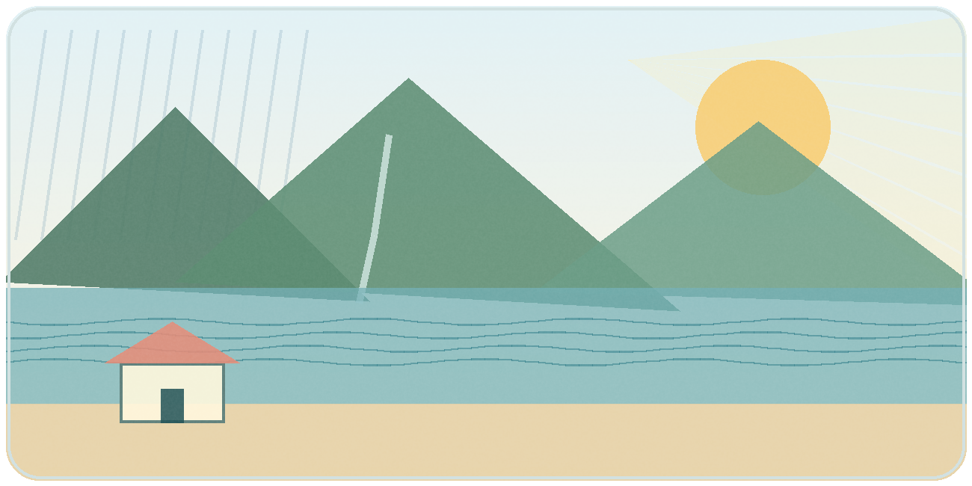
A home on Kauaʻi. Illustration retained from the original report.
Between 2021 and 2026, the ground shifted beneath Alzheimer’s care. New blood-based diagnostic aids made earlier, less invasive evaluation more realistic for people who already had symptoms. New treatments showed that selected people with early Alzheimer’s disease might have options to slow decline, even though the treatments were not cures and required careful monitoring. CMS launched GUIDE, built around dementia care navigation and caregiver support. Congress considered ASAP and AADAPT, bills that spoke to two missing links: access to modern testing and access to trained providers.
These developments gave Hawaiʻi useful tools, but the connections were still missing. A test result did not arrange a follow-up visit. A training session did not find respite for a tired caregiver.
In the future imagined here, Hawaiʻi began connecting those steps. A referral had an owner. A family received an explanation and a plan. Someone checked whether the recommended service had actually been reached.
That was the purpose of HANAI in this story. The word hānai suggested the care and attention families hoped to find. The work was to make that promise dependable.

Chapter 3 The call that changed the room
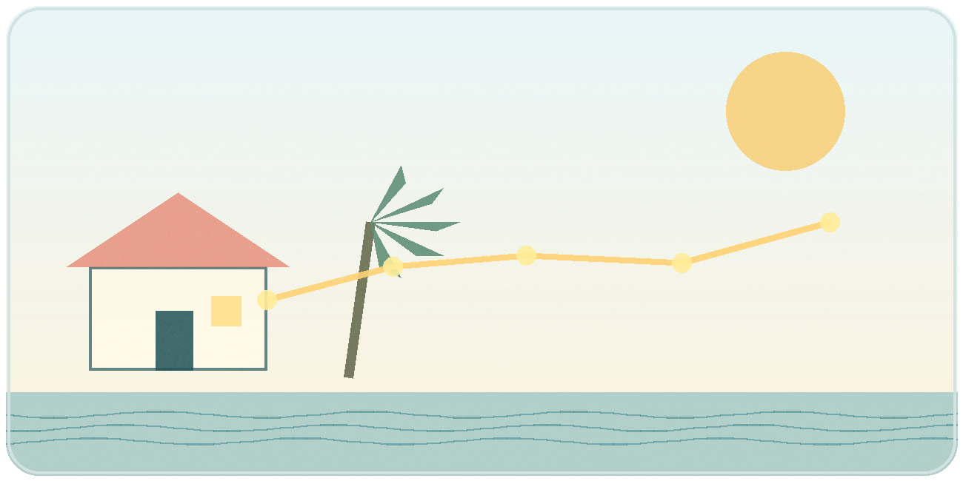
Reaching help from home. Illustration retained from the original report.
Leilani called after breakfast. She expected a menu, a recording, a message saying someone would get back to her later. Instead, a calm voice answered.
“HANAI Memory Network. This is Malia.”
Leilani had rehearsed what to say, but the words scattered. “It’s my mother. She is forgetting things. I do not know if I am overreacting. I do not know where to begin.”
Malia let Leilani finish, then asked about the medicines and the changes she had noticed. Had Rose fallen? Was she still driving? Who was helping at home? She asked whether anyone needed urgent medical attention before they discussed the next appointment.
Leilani began to sort her concerns into words. Malia asked her to gather the medication bottles, write down a few recent examples, and see whether another family member could join the care discussion. Rose listened from the other side of the table.
Then Malia said the sentence that changed the room: “You did the right thing. We are going to walk with you.”
Leilani wrote Malia’s name beside the number. Then she turned the notebook so Rose could see it. They still had difficult questions ahead, but they would not have to begin every call by explaining everything again.
There was a name beside the number now.

Chapter 4 The appointment that almost failed
The first appointment almost failed. A storm moved across the island, the road near Hanalei slowed, and Rose woke up certain that she did not want to go. “I am not sick,” she said. “I just forgot one thing.”
Leilani reached for the phone. Malia listened, then asked to speak with Rose. She explained that the visit would help the family understand the changes Rose had noticed. Rose could ask questions and say what worried her.
The clinic shifted the first visit to telehealth, with an in-person follow-up scheduled if the clinical team needed it. Rose’s son in Nevada joined by video. Dr. Keoni, a primary care physician on Kauaʻi who had completed dementia training and joined Project ECHO sessions with specialists on Oʻahu, appeared on the screen with a calm face and a yellow legal pad.
Dr. Keoni asked about Rose’s garden, then about her sleep, medicines, and daily routines. He listened to Leilani’s examples and asked her brother what he had noticed during phone calls. Memory questions were one part of a longer conversation.
They did not have an answer by the end of the visit. They had a plan for the in-person assessment, and Rose knew the doctor she would be seeing. The storm had not sent them back to the beginning.

Chapter 5 A blood draw and more questions
At the clinic the following week, Rose rolled up her sleeve. “All this from my blood?” she asked.
“Not all,” Dr. Keoni said. “This test gives us one piece of information. We need to look at it alongside your symptoms, examination, and memory testing. Then we can talk about what to do next.”
Leilani watched the vial fill. She was grateful the blood draw could be done close to home. She also knew they would have to wait for the result.
When Dr. Keoni called, he explained that the result supported further evaluation. It did not answer every question about the cause of Rose’s difficulties or which treatments might suit her. Malia helped arrange the next appointment while the clinic continued the assessment.
Leilani felt frightened, but she did not have to turn that fear into another midnight search. She wrote her questions in the notebook and knew who would answer them.

Chapter 6 The result that needed a team
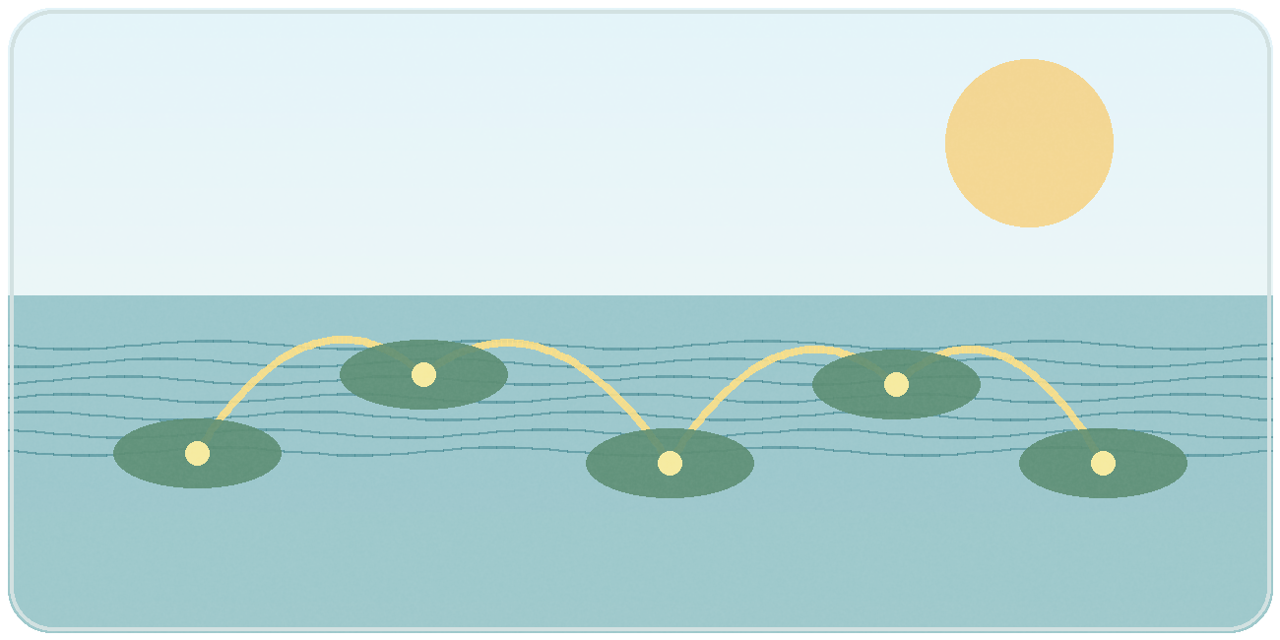
Sharing expertise across islands. Illustration retained from the original report.
Dr. Keoni and Malia reviewed what the family needed next. The clinical questions would take time, but several practical problems could be addressed now.
Dr. Keoni reviewed the medications and found two that might worsen confusion. Malia completed a caregiver assessment with Leilani and discovered that she had not slept through the night in months. The clinic nurse asked about falls and hydration. The social worker asked about legal papers, transportation, food, respite, and whether the family had someone who could help if Rose wandered.
The team divided the work and told Leilani who would contact her. She had been carrying most of those questions herself. Now they had names and dates beside them.
Could Rose be considered for treatment that might slow decline? Dr. Keoni explained that they first needed to confirm the diagnosis, stage, and relevant test findings. They would also need to discuss risks, monitoring, and Rose’s own preferences. “We’ll work through it,” he said. “You don’t have to decide today.”

Chapter 7 Knowledge crosses the ocean
On Thursday afternoon, Dr. Keoni joined a Project ECHO session. On the screen were clinicians from Oʻahu, Maui, Kauaʻi, Hawaiʻi Island, and Molokaʻi. There was a geriatrician, a neurologist, a pharmacist, a social worker, a care navigator, and primary care providers who had brought de-identified cases. No one pretended to know everything. That was the strength of it.
“Move knowledge, not patients,” the ECHO director said. “That is how we serve Hawaiʻi.”
Dr. Keoni presented the case without Rose’s name or identifying details. The group discussed medication review, caregiver support, and the next diagnostic steps. They also considered when specialist assessment would be needed.
The pharmacist raised a medication concern. A social worker suggested a virtual support group. The neurologist helped clarify the referral criteria, and another clinician shared a practical safety checklist. Dr. Keoni wrote down the points he would review with Rose and Leilani.
By the end of the session, Dr. Keoni had a clearer plan. Rose did not have to fly to Honolulu for every answer. The expertise had come to Kauaʻi.

Chapter 8 Mālama becomes a plan
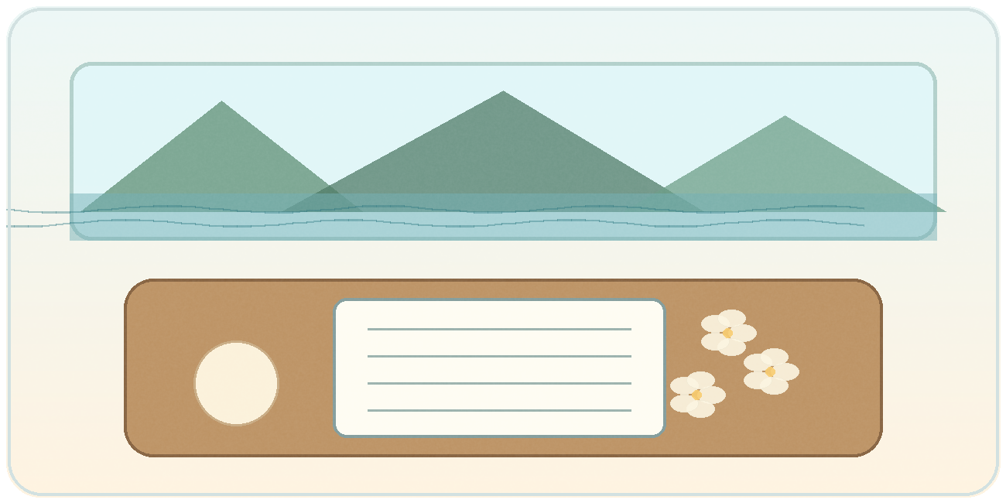
A care plan that can be used at home. Illustration retained from the original report.
Malia came to the Akana home with a folder, a tablet, and the patience of someone who understood fear. She sat at the kitchen table where Rose had taught grandchildren to roll laulau and where Leilani now kept a notebook full of appointments.
The plan listed the questions still being investigated, medicines to review, safety steps, and follow-up dates. It also included transport arrangements, respite options, and people to contact. Malia asked Leilani about her sleep and what help she could realistically accept.
“This is not just for your mother,” Malia said. “This is for you too.”
Rose traced one finger across the printed page. “So this is what we do next?”
“This is what we do next,” Malia said. “If something changes, call me. We’ll update it.”
Leilani put the plan beside the telephone. For once, she did not need to copy instructions from several scraps of paper. She could see the next appointment and the number to call if the night became difficult.

Chapter 9 The night the system was tested

Support after hours. Illustration retained from the original report.
The test came at 1:17 in the morning. Leilani woke to a soft chime from the sensor near the front door. Rose had opened it and stepped onto the porch, confused by a dream that she needed to catch a bus to a job she had retired from twenty years earlier.
Leilani found her standing in slippers, looking toward the road. “I am late,” Rose said, shivering.
Leilani brought her mother inside and called the after-hours line listed in the plan. The nurse asked about the timing of the confusion, possible injury, illness, and other urgent symptoms, and helped her decide whether immediate assessment was needed. In this imagined episode, Rose settled and the nurse arranged follow-up. New or sudden confusion would require prompt medical assessment.
By morning, Malia had called to review the nighttime plan. The door alert had given Leilani time to respond. The team now had another concern to investigate and a safety plan to adjust.
The sensor had done one small job. Leilani and the care team had done the rest. She was glad it had worked, and glad she had known whom to call.

Chapter 10 The Capitol and the canoe
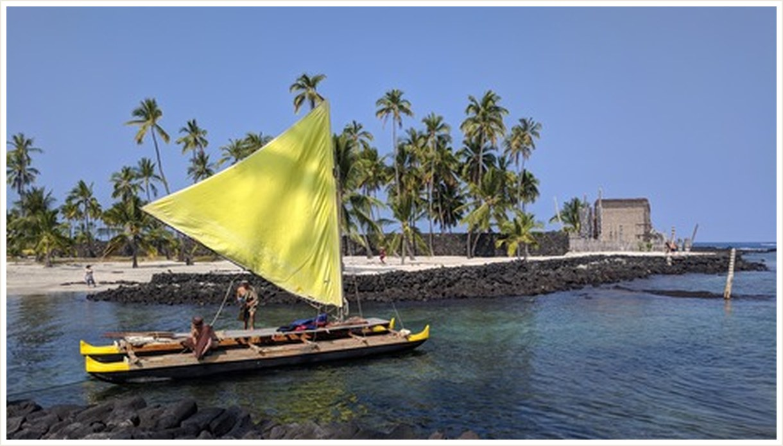
Hawaiian canoe. Photograph credited in the original report to the National Park Service.
Years earlier, in hearing rooms at the Hawaiʻi State Capitol, legislators and advocates had spoken of rising dementia cases, neighbor-island access gaps, caregiver collapse, Medicaid pressure, workforce shortages, and the moral cost of waiting until families broke.
Rep. Gregg Takayama and other House sponsors helped move the HANAI Memory Network concept through the Legislature. Senators including Joy San Buenaventura, Dru Kanuha, and Sharon Moriwaki helped move dementia-related policy through the Senate process. Advocates brought facts. Families brought names. Clinicians brought the memory of patients they could not help soon enough.
When Leilani later heard the network described as a canoe, she understood the image. Research, funding, clinical care, and family support each had a part in moving it forward. If the services worked at different speeds or in different directions, the family felt the strain.
A law could authorize a program. People still had to staff it, make the calls, and follow through. Leilani thought of Malia, who had called back when she said she would.
The promise became real in the follow-through.

Chapter 11 What the dashboard revealed
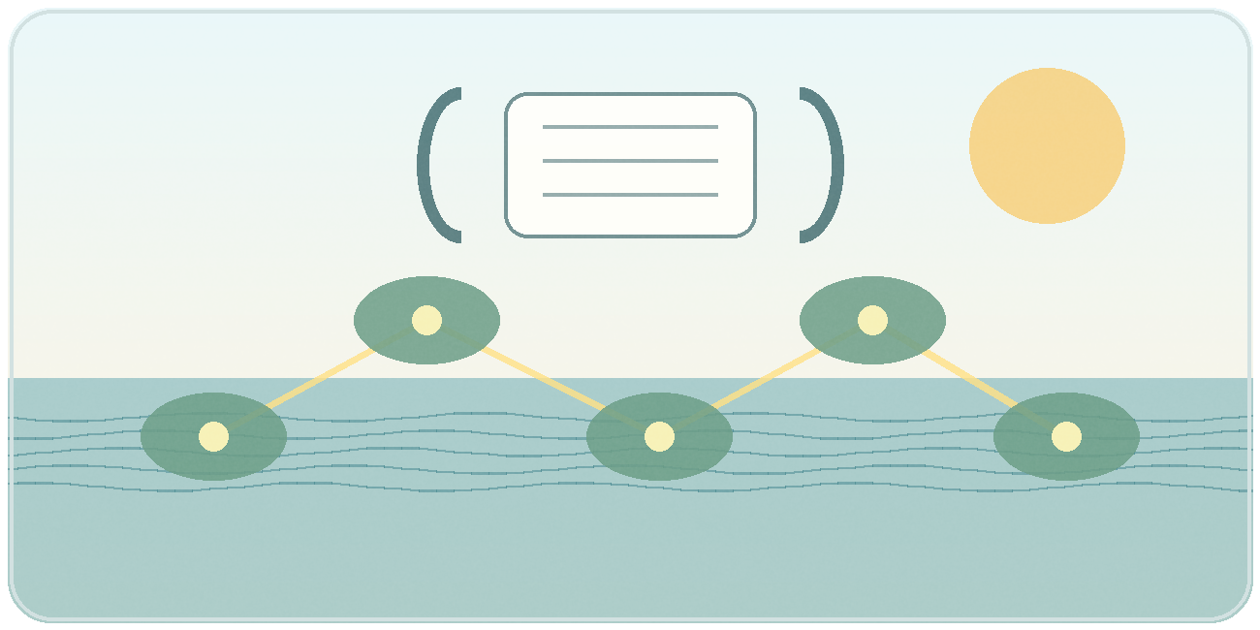
Learning from families’ experience. Illustration retained from the original report.
In Honolulu, a HANAI dashboard began to show patterns no single family could see. Kauaʻi had improved follow-up times. Hawaiʻi Island still had a backlog. Maui had strong caregiver-education completion but slower referral closure. Molokaʻi needed a different outreach strategy because families were not entering through the same front door.
Malia looked at the waiting times and thought of the people behind them. A delay could mean another week of missed sleep or another appointment the family could not arrange. The numbers helped her see where the service was letting people down.
The dashboard found one problem quickly: families who entered through emergency departments were less likely to receive caregiver assessment within 30 days. HANAI changed the workflow. Discharge summaries began to trigger a navigator alert. DCS staff called within a week. The next month, the gap narrowed.
Leilani was relieved to hear that the network had changed its follow-up process. Her mother’s experience, alongside those of other families, had helped identify a gap. The next family might receive that call sooner.

Chapter 12 Sharing the model beyond Hawaiʻi
The first national visitors came quietly. A rural state wanted to know how ECHO helped neighbor-island providers. A large urban state wanted the caregiver assessment and referral-closure dashboard. A tribal health leader asked how the model could respect sovereignty and language. A state Medicaid director wanted to know how small reductions in avoidable crisis use could justify a navigation investment.
The Hawaiʻi team explained which arrangements had helped and which still needed work. Visitors would have to adapt the approach to their own communities. Having roads between clinics would solve some problems; it would not solve every problem.
The team shared care-plan templates, training materials, data definitions, sample contracts, and a first-year calendar. Other states adjusted the design to their services and populations. They kept the same practical expectation: a family should know who was helping and what would happen next.
The work that began across island channels was being tested in other communities.

Chapter 13 The 2050 letter

Sunrise from Hōlua Cabin. Photograph credited in the original report to the National Park Service.
In the imagined year 2050, Leilani’s granddaughter opened a recording Rose had made years earlier. In this hopeful version of the future, evaluation and treatment had improved, and more families could get help close to home. Home technology required less effort, and care teams used it more carefully.
Dementia had not disappeared. Families still faced grief and difficult decisions. But fewer had to wait for a crisis before receiving support, and more caregivers had someone to call before exhaustion took over.
The granddaughter heard Rose’s voice through the speaker: “If you are hearing this, I hope the world has learned to remember the people who are forgetting. I hope it has learned to walk with them.”
Leilani closed her eyes. She remembered the open pill bottle, her mother on the porch, and the notebook beside the telephone. What stayed with her was Malia’s voice on the first morning, patient enough to let her find the words.

Epilogue Hope in daily practice
Rose and Leilani are fictional. The needs illustrated by their story are the needs this proposal is intended to address: timely evaluation, clear explanations, dependable help, and support that continues as circumstances change.
For the family, the test is simple. Does someone listen? Is there a workable next step? Does help arrive when it is needed?
Hawaiʻi can build toward that standard now, while research continues. Hope takes practical form in a completed referral, an understandable care plan, and a caregiver who can finally rest.

Actions readers can take
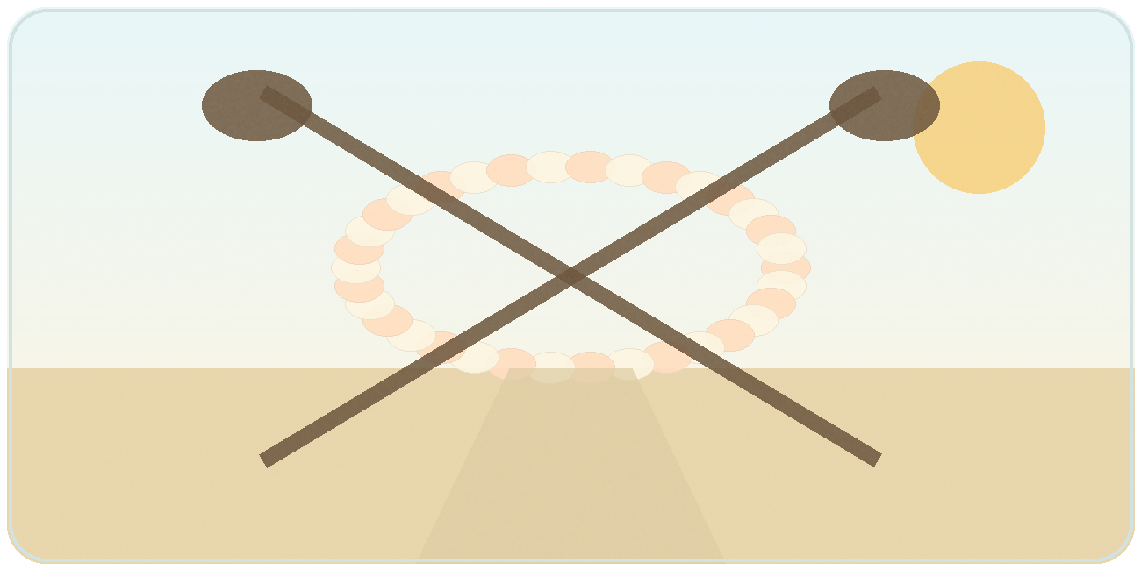
Working together. Illustration retained from the original report.
Readers can help make a more connected system possible through the work and relationships they already have.
- If you are a family member or caregiver: do not wait for crisis. Write down the changes you see, ask for a cognitive evaluation, request a care plan, and ask who will help you navigate next steps.
- If you are a clinician: make memory concerns part of routine care, complete dementia-focused training, use evidence-based diagnostic pathways, and connect families to navigation and community supports immediately after concern or diagnosis.
- If you are a policymaker: support ASAP, AADAPT, GUIDE-style navigation, Project ECHO expansion, and sustainable funding for the HANAI Memory Network with island-specific performance measures.
- If you lead a health system, clinic, or plan: build closed-loop referrals, assign named owners for dementia workflows, train front-door staff, and measure follow-up, caregiver assessment, referral closure, avoidable emergency use, and family experience.
- If you work in technology or data: design tools that protect dignity, support consent, reduce caregiver burden, integrate with care plans, and help the system learn without turning people into data points.
- If you are a community leader, faith leader, employer, or neighbor: normalize early conversation, reduce stigma, support respite, make public spaces dementia-aware, and remind caregivers that accepting help is not weakness.
- If you are a reader with influence: share this story. Ask whether your community has a clear path from memory concern to evaluation, diagnosis, navigation, care planning, caregiver support, and follow-up. If the answer is no, help build it.
Start with one gap you can help close, and stay involved long enough to see whether the change helps.

Closing blessing

Plumeria in Hawaiʻi. Photograph credited in the original report to Bgabel.
May every person living with dementia be met with patience and respect. May caregivers find rest, steady help, and people who listen. And may those entrusted with improving care remember the families waiting for that work to reach them. Good health, good thinking, and hope for the road ahead.

Glossary
Plain-language definitions for terms used in the report. The glossary supports reading and discussion; clinical decisions belong with the person’s care team.
Term / Phrase | Definition / Description
AADAPT training pathway | The provider-training lane of the continuum: structured dementia education, case-based learning, and practical support so frontline clinicians can act on earlier detection.
Addressable baseline cost | The portion of dementia-related spending that a pilot can plausibly influence, such as avoidable emergency use, hospitalizations, caregiver crisis, and some long-term care transitions.
Alzheimer's disease | A progressive brain disease and the most common cause of dementia; it affects memory, thinking, judgment, behavior, and daily function.
Alzheimer's disease and related dementias | A collective term for Alzheimer's disease and other dementias, including vascular dementia, Lewy body dementia, frontotemporal dementia, and mixed dementias.
Amyloid | A protein that can accumulate in plaques in the brain and is one of the biological markers used in evaluating Alzheimer's disease.
Anti-amyloid therapy | A treatment approach intended to reduce amyloid plaques in selected people with early Alzheimer's disease; it is not a cure and requires careful eligibility and safety monitoring.
Aloha | In this report, a shorthand for compassionate, relationship-centered care that treats people with dementia and caregivers with dignity.
ASAP front door | The early-detection entrance into the continuum, centered on appropriate access to FDA-approved or FDA-cleared blood-based Alzheimer's diagnostic aids when clinically indicated.
Avoidable emergency use | Emergency-room or emergency-department visits that may be reduced through earlier care planning, medication support, caregiver education, safety planning, and timely navigation.
Biomarker | A measurable biological signal, such as amyloid or tau-related pathology, that can support diagnosis, staging, research, or treatment decisions when used in clinical context.
Blood-based diagnostic aid | A blood test used as one component of Alzheimer's evaluation; it supports, but does not replace, clinical judgment, cognitive assessment, and appropriate follow-up.
Break-even calculation | Annual program cost divided by annual addressable baseline cost, multiplied by 100, gives the percentage reduction needed to cover the program cost within that baseline.
Care continuum | A connected pathway from memory concern to screening, diagnosis, navigation, care planning, caregiver support, community services, monitoring, measurement, and continuous improvement.
Care maintainer | A HANAI role that keeps the plan alive over time by checking whether services, safety steps, caregiver supports, and follow-up are still working.
Care manager | A coordinating role that helps connect clinical care, social support, caregiver needs, referrals, and escalation when risk increases.
Care navigation | Hands-on guidance that helps a family understand the diagnosis, complete next steps, connect with services, and know who to contact when problems arise.
Care plan | A written, practical plan that records diagnosis status, medications, safety steps, caregiver needs, referrals, follow-up dates, and escalation instructions.
Care planner | A HANAI role that converts a diagnosis or memory concern into an understandable plan for the person, caregiver, clinician, and navigator.
Caregiver assessment | A structured check of caregiver strain, needs, safety concerns, respite needs, and ability to continue supporting the person with dementia.
Clinical evaluation | The medical process of reviewing history, symptoms, cognitive testing, medications, laboratory information, imaging or biomarker information when appropriate, and functional changes.
Closed-loop referral | A referral that is tracked until completion, so the system knows whether the family actually reached the service rather than merely receiving a phone number.
Community pathway | A route into the continuum that may begin outside a doctor's office, such as through senior centers, public agencies, community organizations, caregiver calls, or outreach events.
Crisis response | A reactive pattern in which families receive help only after an emergency, hospitalization, unsafe event, or caregiver collapse.
Dashboard governance | The discipline of using common definitions, named owners, regular reporting, and transparent review to improve access, outcomes, equity, and cost performance.
Data dictionary | A shared list of data elements, definitions, and formats so clinics, navigators, agencies, and technology systems can measure the same things in the same way.
Dementia | A broad term for serious decline in memory, thinking, judgment, behavior, or daily function that interferes with independence.
Dementia care specialist | A trained professional who helps assess needs, coordinate services, support caregivers, and keep families connected to the continuum.
Demonstration state | A state used to prove a model under real-world conditions before adapting it more broadly; the report presents Hawai'i as a strong test case because of its geography and access challenges.
Disease-modifying treatment | A treatment intended to affect the underlying disease process, not only symptoms; current therapies have specific eligibility, monitoring, risk, and access requirements.
Early detection | Identifying memory concerns or disease signals sooner, when planning, treatment evaluation, risk reduction, caregiver support, and safety steps can begin earlier.
Early-stage Alzheimer's disease | The stage at which symptoms are present but the person may still have substantial independence; this is the stage in which current disease-modifying treatments are generally evaluated.
Equity reporting | Performance reporting that looks at access and outcomes by island, county, community, or population group so statewide averages do not hide gaps.
FDA-cleared / FDA-approved | Regulatory terms indicating that the Food and Drug Administration has cleared or approved a product for specific uses; they do not mean the product is appropriate for every person.
FHIR-ready data | Data designed so it can later map to health-information exchange standards and electronic health records, even if the first pilot uses a simpler data system.
Front door | The first reliable entry point into the continuum, whether through primary care, community outreach, a blood test pathway, a navigator, or a memory clinic referral.
HANAI Memory Network | Hawaiʻi memory-network initiative; this report proposes how its specialists, clinics, referrals, public education, and caregiver support could work together.
Hawai'i model | The integrated continuum proposed in the report: early detection, trained providers, Project ECHO, GUIDE-style navigation, HANAI services, technology support, and measurable governance.
Hānai | A Hawaiian word associated with nurturing, feeding, fostering, or taking into family relationship; the report uses the concept to emphasize a caring, not merely transactional, system.
Hospitalization rate | A measure of inpatient admissions over a defined population and time period; the report uses it as one outcome that could improve through better dementia support.
Hub-and-spoke learning | A training model in which specialist teams support community providers through virtual sessions, case discussion, and shared learning.
Interdisciplinary team | A care team that may include physicians, nurses, social workers, navigators, pharmacists, community partners, and specialists working from one plan.
Islandwide memory services | Memory-care access organized so each island has a practical pathway for evaluation, care planning, referrals, and follow-up.
Key performance indicator | A measurable indicator used to determine whether the continuum is working, such as follow-up time, referral closure, caregiver assessment rate, or avoidable ER use.
Kuleana | A Hawaiian concept of responsibility and stewardship; the report uses it to describe shared responsibility for kupuna, caregivers, and public systems.
Kūpuna | Elders or older adults; in the report, the people the continuum is designed to protect, honor, and support.
Learning system | A care system that uses data, feedback, outcomes, and family experience to improve continuously rather than repeating the same gaps.
Lōkahi | A Hawaiian concept of unity, harmony, and alignment; the report uses it to describe the need to connect separate programs into one continuum.
Mālama | To care for, protect, or tend; in the report, it describes the moral and operational purpose of the continuum.
Mana'olana | Hope; in the report, hope made practical through early action, navigation, caregiver support, measurement, and scientific progress.
Memory clinic | A clinical setting or contracted partner that provides cognitive evaluation, diagnosis support, staging, treatment assessment, and care-planning connection.
National rollout | The process of adapting the Hawai'i pilot into a simpler version that other states can implement using their own geography, workforce, Medicaid structures, and community assets.
Neighbor islands | The Hawai'i islands outside O'ahu, often facing greater specialty-access, travel, and workforce constraints.
No wrong door | An operating rule that a family should be connected to the right next step regardless of whether they enter through a clinic, agency, community group, emergency discharge, or caregiver call.
'Ohana | Family, broadly understood; the report uses it to include relatives, caregivers, trusted supporters, and the circle of people affected by dementia.
Pilot | A disciplined, measurable first implementation used to test workflows, costs, data, outcomes, equity, and scalability before wider adoption.
Primary care pathway | The route into the continuum that begins when a primary care provider recognizes memory concern, orders or interprets appropriate tests, and refers for follow-up.
Project ECHO | A virtual case-based mentoring model that moves specialist knowledge to community providers rather than requiring every patient to travel to specialists.
pTau181 | A phosphorylated tau biomarker that can be used in certain blood-based Alzheimer's assessment contexts as one signal of disease-related pathology.
Remote monitoring | Technology-enabled observation of selected safety or health signals, such as falls, medication adherence, sleep disruption, or wandering risk, with consent and dignity safeguards.
Respite | Temporary relief for caregivers through services or supports that allow the caregiver time to rest, work, recover, or manage other responsibilities.
Risk reduction | Actions that may lower dementia risk or delay decline at a population level, such as managing cardiovascular risk, hearing loss, diabetes, depression, isolation, sleep, and other modifiable factors.
Staging | Determining the level or phase of cognitive impairment and functional impact so treatment, care planning, safety steps, and support match the person's needs.
Statewide platform | A common operating structure across islands and agencies that provides consistent referral pathways, service expectations, data definitions, and accountability.
Technology layer | Telehealth, remote monitoring, wearables, medication tools, data integration, dashboards, and AI-supported workflows used to extend and improve human care.
Telehealth | Care or consultation delivered through secure phone or video tools, especially important when travel and specialist availability create access barriers.
Wearables | Devices worn by a person, such as a watch or pendant, that may support fall detection, activity trends, safety alerts, or remote monitoring when used appropriately.

Acronym Dictionary
Abbreviations used in the policy framework, source notes, and implementation discussion.
Acronym | Full Term | Use in This Report
AADAPT | Accelerating Access to Dementia and Alzheimer's Provider Training Act | Federal workforce-training proposal referenced as a way to expand structured virtual dementia education.
AD | Alzheimer's disease | Used when referring specifically to Alzheimer's disease rather than all dementias.
ADRC | Aging and Disability Resource Center | A community access point for aging, disability, caregiver, and long-term services information.
ADRD | Alzheimer's disease and related dementias | Umbrella term for Alzheimer's disease and other dementia-related conditions.
AI | Artificial intelligence | Technology that may support triage, data review, care-navigation prompts, documentation, and forecasting; it should not replace clinical judgment.
AIM | Alzheimer's Impact Movement | Advocacy organization cited in the source notes for federal policy information.
APRN | Advanced Practice Registered Nurse | Advanced nursing clinician role referenced in the HANAI staffing concept and memory-clinic model.
ASAP | Alzheimer's Screening and Prevention Act | Federal proposal referenced as the early-detection and blood-test coverage front door.
BOLD | Building Our Largest Dementia Infrastructure for Alzheimer's Act | Public-health infrastructure law used in the report to frame state and local dementia capacity.
CDC | Centers for Disease Control and Prevention | Federal public-health agency cited for BOLD infrastructure and dementia public-health framing.
CMS | Centers for Medicare & Medicaid Services | Federal agency responsible for Medicare, Medicaid, and the GUIDE Model.
DCS | Dementia Care Specialist | Role embedded in the HANAI concept to support families, referrals, care planning, and coordination.
DO | Doctor of Osteopathic Medicine | Physician credential used in the memory-clinic staffing model in the HANAI source concept.
DOH | Department of Health | State health agency role referenced in public-health and implementation context.
ECHO | Extension for Community Healthcare Outcomes | Virtual hub-and-spoke mentoring model used to move dementia knowledge to community providers.
ED | Emergency Department | Hospital emergency department; used in relation to crisis response and avoidable emergency utilization.
EHR | Electronic health record | Clinical information system that can receive or exchange FHIR-ready data in later implementation phases.
EOA | Executive Office on Aging | Hawai'i state aging office referenced as a coordinating entity in the HANAI source concept.
ER | Emergency Room | Emergency care setting; the report uses reduced avoidable ER use as a potential outcome measure.
FDA | Food and Drug Administration | Federal agency that clears or approves diagnostic aids, treatments, and other regulated medical products for specific uses.
FHIR | Fast Healthcare Interoperability Resources | Health-data exchange standard used in the report's data-dictionary and scalability logic.
FQHC | Federally Qualified Health Center | Community health-center model that may serve as a front door for dementia care in underserved areas.
GUIDE | Guiding an Improved Dementia Experience Model | CMS model emphasizing dementia care navigation, caregiver support, care planning, and 24/7 access.
HANAI | HANAI Memory Network | The named Hawaiʻi memory-network initiative; hānai also carries meanings of nurturing and care.
HB1853 | Hawai'i House Bill 1853 | State legislative vehicle referenced in the source notes for the HANAI Memory Network concept.
HL7 | Health Level Seven International | Standards organization associated with FHIR and health-information exchange.
IBM | International Business Machines | Former employer referenced in the author's professional background.
JAMA | Journal of the American Medical Association | Medical journal family cited in the source notes for evidence related to dementia-care program findings.
KPI | Key performance indicator | Metric used to measure flow, equity, experience, outcomes, and costs in the continuum.
LSW | Licensed Social Worker | Social-work credential referenced in the memory-clinic staffing concept.
LTSS | Long-term services and supports | Home, community, and institutional supports that help people with functional limitations and caregiver needs.
MD | Doctor of Medicine | Physician credential used in the memory-clinic staffing model in the HANAI source concept.
MRI | Magnetic resonance imaging | Imaging method that may be used in diagnostic workups or safety monitoring depending on clinical context.
NAPA | National Alzheimer's Project Act | Federal law establishing a coordinated national plan to address Alzheimer's disease.
NIA | National Institute on Aging | NIH institute cited for Alzheimer's and related dementias research and clinical-trial information.
NIH | National Institutes of Health | Federal biomedical research agency referenced in relation to future treatment and prevention science.
NPS | National Park Service | Source of public-domain Hawai'i photographs used in the report.
PCP | Primary care provider / primary care physician | Frontline clinician role that can identify memory concerns, begin evaluation, and refer into the continuum.
PDF | Portable Document Format | Fixed-layout document format used for the preview/export version of this report.
PET | Positron emission tomography | Imaging method that can detect amyloid or other pathology but may be less accessible than blood-based aids in some communities.
PMP | Project Management Professional | Professional credential referenced in the author's background.
RN | Registered Nurse | Nursing role referenced in the HANAI memory-clinic staffing concept and clinical-care context.
UCLA | University of California, Los Angeles | Institution referenced in the source notes for dementia-care program findings.
USGS | U.S. Geological Survey | Source of a public-domain Kaua'i image used in the report.

Source Notes
The sources below support the report’s main policy and clinical concepts. References 1–8 are cited at key points in the text. The report also contains author recommendations, planning assumptions, and fiction; these should not be read as measured program results. The 2050 scenarios and phase-in budget levels are illustrative.
- [8] Supplied HANAI Memory Network infographic, dated August 28, 2025. Source for the original county specialist and neighbor-island clinic concept, minimum clinic staffing, Executive Office on Aging coordination, and proposed $3 million annual budget.
- Original author report and visual summary, Building America’s Alzheimer’s Continuum of Care. Source of the policy design and illustrative phase-in assumptions retained in this edition.
- [1] Alzheimer’s Association. 2026 Alzheimer’s Disease Facts and Figures. National prevalence, caregiving, and spending estimates; the spending total excludes unpaid care. Read source
- [2] FDA. FDA Clears First Blood Test Used in Diagnosing Alzheimer’s Disease. May 16, 2025. Lumipulse intended population, diagnostic-aid role, and limits. Read source
- [3] FDA. FDA Converts Novel Alzheimer’s Disease Treatment to Traditional Approval. July 6, 2023. Leqembi approval and treatment population. Read source
- [4] FDA. FDA Approves Treatment for Adults with Alzheimer’s Disease. July 2, 2024. Kisunla approval and safety considerations. Read source
- [5] Alzheimer’s Impact Movement. The Alzheimer’s Screening and Prevention Act. Policy purpose and legislative information. Read source
- [6] Alzheimer’s Impact Movement. AADAPT Act. Proposed support for structured virtual dementia education. Read source
- LegiScan, Hawaiʻi HB1853 bill text. Used for HANAI Memory Network purpose, community-based specialists, clinical partnerships, public education, early detection, care coordination, and long-term support. Read source
- Alzheimer’s Impact Movement. Hawaiʻi advocacy page. Background on state policy priorities; historical figures in the original report should not be treated as a current Hawaiʻi prevalence estimate. Read source
- CDC, BOLD Infrastructure for Alzheimer’s Act. Used for public-health infrastructure framing: risk reduction, early detection and diagnosis, prevention of avoidable hospitalizations, and caregiving. Read source
- Alzheimer’s Association, National Alzheimer’s Project Act. Used for NAPA signing date and national plan framing. Read source
- [7] CMS. Guiding an Improved Dementia Experience Model. Services, participation, and beneficiary eligibility. Read source
- Alzheimer’s Association, Alzheimer’s and Dementia Care ECHO Program. Used for ECHO dementia training framing, team-based approach, geographic barrier reduction, and timely diagnosis focus. Read source
- Project ECHO, ECHO Model. Used for “All Teach, All Learn” and hub-and-spoke learning model framing. Read source
- HL7 FHIR CarePlan and Observation documentation. Used for FHIR-ready data dictionary logic. Read source and Read source
- Lancet Commission, “Dementia prevention, intervention, and care: 2024 report.” Used for prevention/risk-reduction framing and 14 modifiable risk factors that may delay or prevent a substantial share of dementia cases. Read source
- National Institute on Aging, active Alzheimer’s and related dementias clinical trials. Used for the future-breakthrough section and the breadth of ongoing research. Read source
- NIH Research Matters, “Blood test predicts start of Alzheimer’s disease symptoms,” March 17, 2026. Used for future biomarker scenario framing; not used as a current clinical-service recommendation. Read source
- JAMA Internal Medicine / UCLA Alzheimer’s and Dementia Care Program findings. Used for cautious financial logic that comprehensive dementia care may reduce long-term care admissions and may be cost neutral or cost saving depending on program costs. Read source
- Visuals in this edition include retained Hawaiʻi photographs and scene illustrations, plus new care-pathway, service-design, and financial graphics. New diagrams describe the report’s proposed model; they do not certify local service availability.
- Photo credit - Kauaʻi coastline: U.S. Geological Survey / Climate Adaptation Science Centers, “Kauaʻi,” public domain. Read source
- Photo credit - Haleakalā sunrise: National Park Service, “Haleakala sunrise from Kalahaku,” public domain. Read source
- Photo credit - Hōlua Cabin sunrise: National Park Service, “Sunrise from Holua Cabin,” public domain. Read source
- Photo credit - Hawaiian canoe in the cove: NPS Photo, “Canoe Rides in the Cove,” public domain. Read source
- Photo credit - plumeria in Hawaiʻi: Bgabel, “Haw-plumeria,” public domain. Read source
- Music direction: For presentation or video production, use a licensed or royalty-cleared instrumental recording or arrangement of “Aloha ʻOe”; keep it soft enough that narration remains clear.
Publishing & Copyright Notice: Written and produced by Girard “Jerry” Perone. Published and distributed by the National Management Center Inc. Copyright © 2026 Girard Perone. All rights reserved. No part of this document may be reproduced, distributed, stored in a retrieval system, or transmitted in whole or in part, in any form or by any means, without prior written permission of the copyright owner, except as permitted by applicable law.

Contact and Additional Information
Use these resources for further reading, family support, policy information, and questions about this report.
Public-policy contact listed in the supplied August 2025 HANAI infographic: Coby Chock, Hawaiʻi Director of Public Policy and Advocacy, Alzheimer’s Association | 808.451.3410 | ckchock@alz.org. Confirm current contact details before outreach.
What you want to do | Where to go first | Website / contact
Understand symptoms and care options | Alzheimer’s Association | Alzheimer’s Association
Follow federal dementia policy | Alzheimer’s Impact Movement | Alzheimer’s Impact Movement
Learn about GUIDE | Centers for Medicare & Medicaid Services | CMS GUIDE Model
Explore dementia public health | CDC BOLD Infrastructure for Alzheimer’s Act | CDC BOLD program
Track HANAI legislation | LegiScan HB1853 / Hawaiʻi legislative history | HB1853 legislative record
Review Hawaiʻi aging and dementia planning | Hawaiʻi State Strategic Plan on ADRD | Hawaiʻi Executive Office on Aging
Check diagnostic and treatment information | U.S. Food and Drug Administration | FDA
Understand health data standards | HL7 FHIR | HL7 FHIR
Request permission to reuse this report | Girard “Jerry” Perone / National Management Center, Inc. | Permission required from the copyright owner before reuse except as permitted by law.
For family support, the Alzheimer’s Association’s 24/7 Helpline is 800.272.3900. Its website also provides local resources and caregiver information.
Good health, good thinking.

