THE COST OF WAITING
Enhanced Publication Version with 180-Day Implementation Feasibility, Figures, and Action Path
Executive Summary
Under the nominal model, Hawaiʻi adds approximately 100 new Alzheimer’s cases and about 166 caregivers every month.
This edition adds a feasibility section showing why a 180-day HANAI implementation target is operationally plausible using infrastructure the Executive Office on Aging already coordinates.
Taken together, the evidence shifts the policy question from whether Hawaiʻi should move quickly to whether Hawaiʻi can justify not moving quickly.

1. Purpose and Scope
This report is designed to stand on its own. It explains where the disease-growth estimates come from, how the cost curves were calculated, how implementation schedule assumptions change the burden, and why a 180-day implementation pathway should be treated as a serious operational target rather than a rhetorical aspiration.

2. Personal and Policy Context
This analysis is rooted in both lived experience and public policy. Alzheimer’s disease has already taken people I love, including my mother and my friend Rich. That reality sharpens the practical question before Hawaiʻi: if the disease is already advancing on a monthly basis, what is the public cost of allowing system response to move at a much slower administrative pace?

3. Baseline Data Used in the Model
The baseline Hawaiʻi caseload used here is 31,200 residents age 65 and older living with Alzheimer’s disease. The unpaid caregiver base is 62,000. Nationally, the model uses 7.2 million people living with Alzheimer’s disease and approximately 12 million unpaid caregivers. Those values generate a Hawaiʻi-specific incidence flow that aligns closely with national scaling.

4. Numbered Equations and Derivations

4.1 Annualized growth-rate equation
(Eq. 1) r = (1 + g)^(1/n) − 1
Using g = 0.207 and n = 5 gives r = 0.0383, or about 3.83% per year.

4.2 Hawaiʻi net-added annual case estimate
(Eq. 2) NetAdded_HI = P_HI × r
Using P_HI = 31,200 and r = 0.0383 yields NetAdded_HI = 1196.3 cases per year.

4.3 Monthly incidence flow
(Eq. 3) i = NetAdded_HI / 12
This gives i = 99.70 cases per month, or about 100 new Alzheimer’s cases per month in public-facing terms.

4.4 Range assumptions
(Eq. 4) i_best = 91, i_nominal = 99.70, i_worst = 104
These bounds bracket uncertainty around the nominal monthly flow.

4.5 Caregiver-demand multiplier
(Eq. 5) CaregiverRatio = 12,000,000 / 7,200,000 = 1.667
(Eq. 6) CaregiversNeeded(t) = Cases(t) × CaregiverRatio

4.6 Cumulative case accumulation by time
(Eq. 7) Cases(t) = i × t
This equation converts delay in months directly into additional Hawaiʻi Alzheimer’s cases.

4.7 Cumulative burden during the waiting period
(Eq. 8) B(t) = i × [t(t + 1) / 2]
This triangular accumulation reflects that cases arriving earlier remain in the system in later months.

4.8 Capacity-gap equation
(Eq. 9) Gap(t) = Cases(t) − Capacity(t)
The capacity gap measures the number of people whose needs are present before the system is ready.

4.9 Cost allocation equations
(Eq. 10) MedicaidBurden(t) = Cases(t) × $9,904
(Eq. 11) HealthcareBurden(t) = Cases(t) × $35,127
(Eq. 12) UnpaidCareValue(t) = Cases(t) × $92,949

5. Plain-English Interpretation of the Mathematics
The formulas above can be read in ordinary language. National disease growth is converted to an annual rate. That rate is applied to Hawaiʻi’s baseline caseload. The annual number is then converted to a monthly flow because implementation delay is experienced month by month. A caregiver multiplier extends the model beyond patients alone. Finally, cost proxies translate human burden into Medicaid, healthcare, and unpaid-care burden.

6. Results by Rollout Duration
Months to full rollout | Additional cases (nominal) | Additional caregivers | Healthcare burden
24 | 2,393 | 3,988 | $84.0M
36 | 3,589 | 5,982 | $126.1M
48 | 4,785 | 7,976 | $168.1M
These results show the direct relationship between rollout speed and human burden. The additional-case count at completion is not an abstract backlog. It is a count of Hawaiʻi residents whose need exists before the network is fully available.

7. Figures and Technical Interpretation

7.1 Figure 1 — Capacity gap under an illustrative 24-month rollout
This figure compares cumulative Alzheimer’s case growth against an illustrative stepwise rollout of four sites over 24 months. The shaded area represents unmet need: people who exist in the system before the system can absorb them.
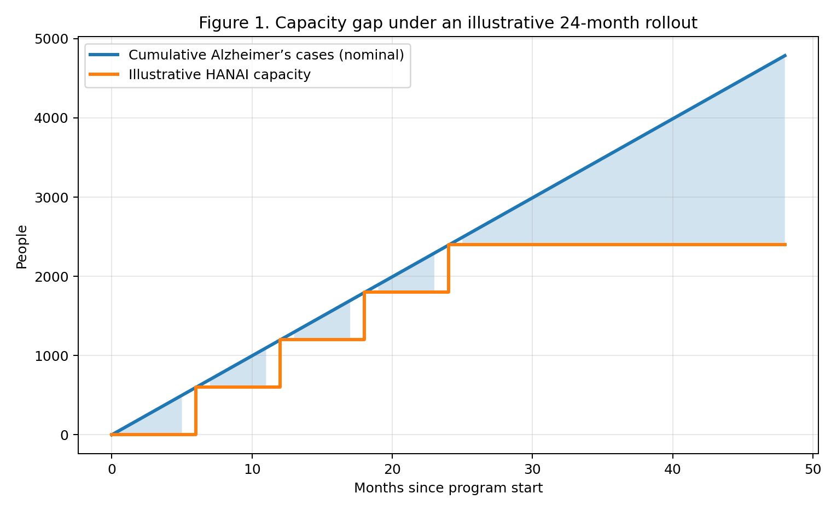
Figure 1 caption. The gap between disease growth and capacity is the central policy problem addressed by HANAI.

7.2 Figure 2 — Cost of waiting over time
This figure converts rising case counts into three cost lenses: Medicaid, combined Medicare plus Medicaid, and unpaid family-care value. Even if one debates exact marginal cost, the direction, scale, and slope of the burden are unmistakable.
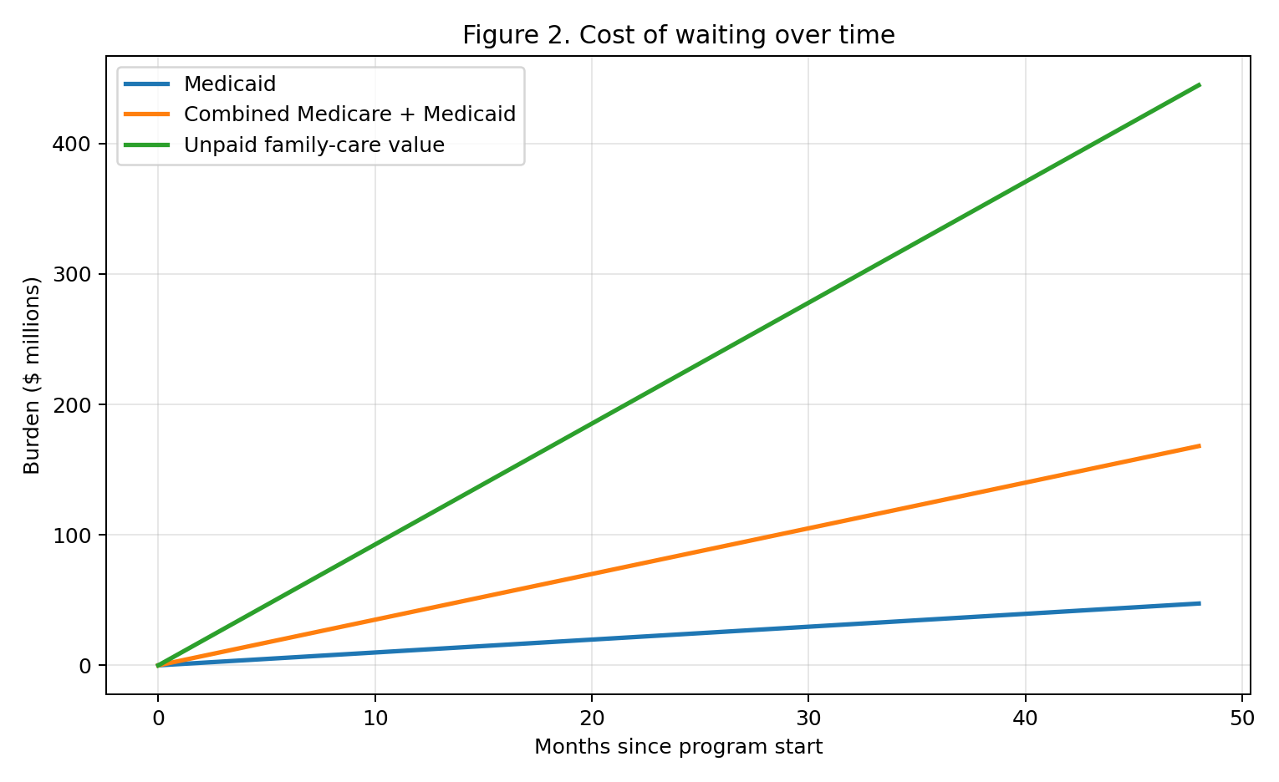
Figure 2 caption. The unpaid-care curve is the largest because dementia shifts substantial labor and stress onto families.

7.3 Figure 3 — Scenario comparison by rollout speed
This figure compares how many additional people are affected when full rollout takes 24, 36, or 48 months. It makes visible the fact that implementation speed affects both patients and caregivers in parallel.
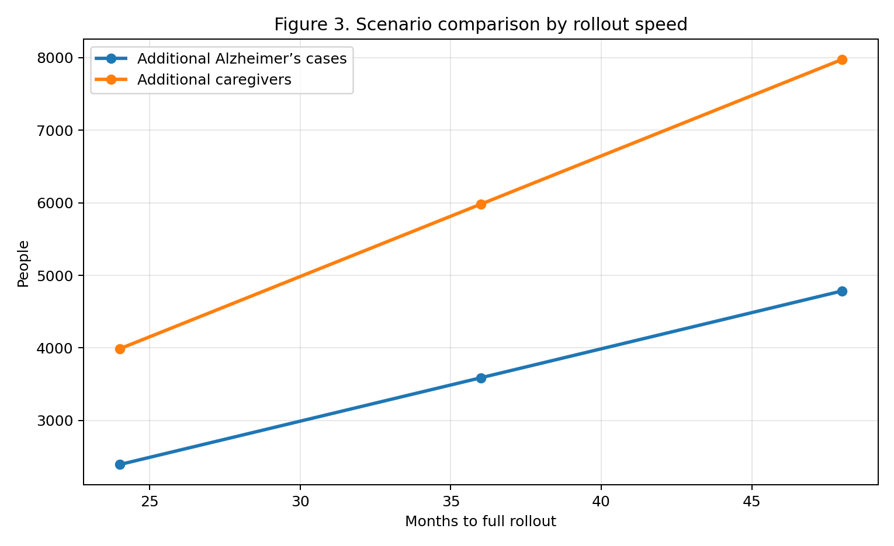
Figure 3 caption. Longer rollout periods create larger case backlogs and larger caregiver loads by the time full capacity is reached.

7.4 Figure 4 — Best, nominal, and worst-case growth assumptions
This range figure demonstrates that even under more optimistic assumptions, delay still creates a large and growing burden. The range is narrow enough to support strong planning conclusions, but transparent enough to acknowledge uncertainty.
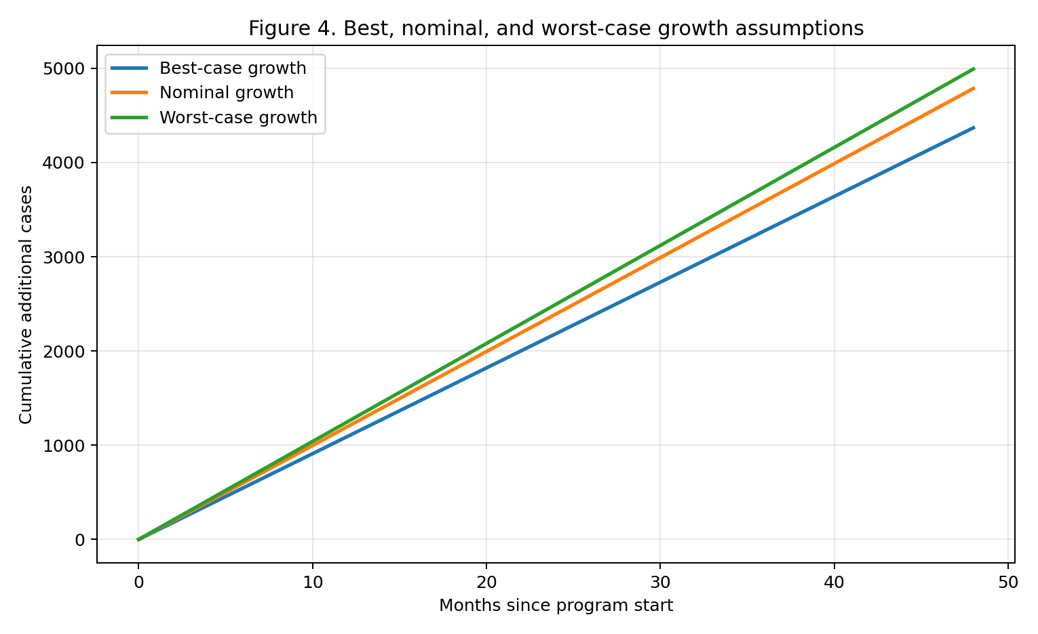
Figure 4 caption. The policy conclusion holds across the full best-to-worst range: delay is costly, measurable, and avoidable.

8. Why a 180-Day HANAI Implementation Is Operationally Feasible
The cost-of-waiting analysis invites the obvious next question: can Hawaiʻi move substantially faster than a conventional 24- to 48-month government timeline? The answer is yes, if HANAI is treated correctly as an integration and activation effort rather than as a greenfield construction project.

8.1 The key reframing
The assumption behind long implementation timelines is that the Executive Office on Aging would need to build a new statewide system from scratch. That assumption is too pessimistic. The Executive Office on Aging is already the designated lead agency in the coordination of a statewide system of aging and caregiver support services in Hawaiʻi. It already works with the four county Area Agencies on Aging, and Hawaiʻi’s Aging and Disability Resource Center structure already operates as a statewide access and navigation layer for older adults, people with disabilities, and family caregivers. The federal No Wrong Door description for Hawaiʻi likewise identifies EOA as the Governor-designated lead working with the AAAs, Med-QUEST, UH, and other state partners.

8.2 Infrastructure that already exists
EOA does not begin at zero. Publicly documented functions already include statewide coordination, work with the four county Area Agencies on Aging, caregiver support alignment, home- and community-based service coordination, ADRC / No Wrong Door access points, and leadership of the Hawaiʻi Dementia Initiative. The Hawaiʻi 2035 ADRD State Strategic Plan already provides policy direction on dementia capability, data, workforce, public awareness, and community coordination. In operational terms, this means that HANAI can be layered onto an existing platform of relationships, intake pathways, referral logic, and community-facing infrastructure rather than waiting for a wholly new architecture.
180-Day Implementation Reality Check
EOA already coordinates a statewide aging and caregiver support system.
The four county AAAs and ADRC / No Wrong Door infrastructure already provide access points, referral channels, and community-facing functions.
The Hawaiʻi Dementia Initiative and the Hawaiʻi 2035 ADRD Strategic Plan mean the policy blueprint already exists.
HANAI therefore requires activation, standardization, and accountability far more than invention.

8.3 What must actually be done in 180 days
A 180-day target should not be understood as the date by which every optimization is complete. It should be understood as the date by which HANAI is functionally live, with a statewide operating model, defined access points, standardized intake and triage, navigation protocols, referral workflows, reporting routines, and pilot-to-scale governance in place. That is an acceleration challenge, but it is not a fantasy.

8.4 A practical 180-day operating sequence
Phase | Days | Core deliverables
Mobilize | 0–30 | Governor / EOA implementation charter; named accountable lead; weekly stand-up cadence; draft workplan; county AAA / ADRC alignment.
Standardize | 31–60 | Uniform HANAI intake, triage, referral, and navigation protocols; training package; reporting template; pilot-site designation.
Activate | 61–120 | Pilot launch through existing access points; live navigation workflows; provider and community referral map; issue log and rapid-cycle correction.
Scale | 121–180 | Cross-island standardization; dashboard reporting; monthly performance review; statewide operating model functionally active.
This is an execution model, not a hiring fantasy. Much of the work is workflow, governance, coordination, and protocol standardization using infrastructure that already exists.

8.5 Figure 5 — 180-day implementation pathway
The following figure shows an illustrative acceleration pathway. It is not a claim that every county will move identically. Its purpose is to show that a 180-day plan is plausible when the effort is organized around activation milestones instead of a slow sequential build.
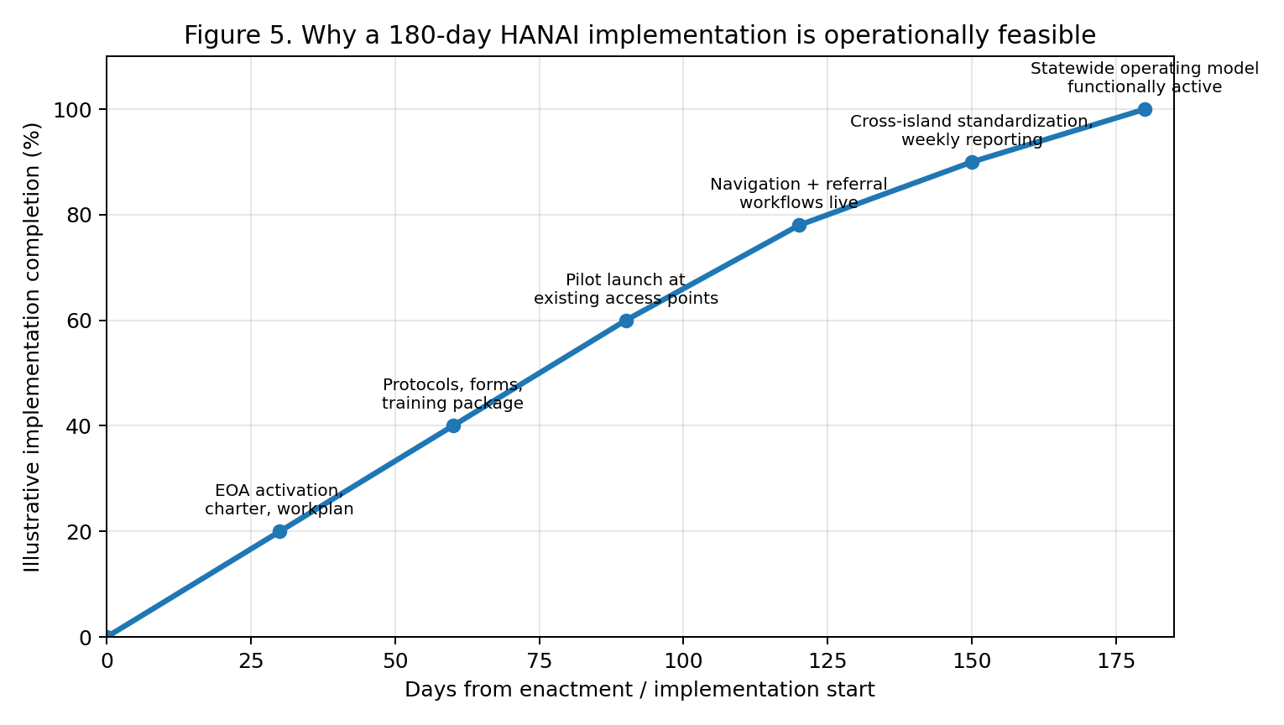
Figure 5 caption. A 180-day target is achievable when the implementation logic uses existing EOA / AAA / ADRC infrastructure and focuses on activation, not construction.

8.6 What would make 180 days fail
A 180-day pathway would fail if leadership is diffuse, if accountability is not named, if counties are left to improvise independently, if reporting is not weekly at first, or if the work is incorrectly defined as a multi-year procurement exercise rather than a managed implementation sprint. In other words, the primary barriers are managerial, not conceptual.

8.7 The policy implication
The evidence in this report changes the burden of proof. After quantifying the monthly cost of delay and documenting the infrastructure already in place, the policy question is no longer “Can EOA theoretically do this faster?” It becomes “What would justify not setting a 180-day operational target?”

9. Why This Matters to Each Stakeholder Group
Families experience the cost of waiting through delayed diagnosis, rising supervision demands, lost work time, emotional strain, and unpaid labor. The State experiences the cost through Medicaid pressure and downstream unmanaged disease. The federal system experiences it through Medicare. Providers experience it as fragmentation and workflow strain. Community organizations experience it as unmet navigation, education, and respite demand. The same monthly delay creates different forms of burden, but all arise from the same underlying case-growth mathematics.

10. Recommended Next Steps to Achieve a 180-Day Target
- Set the target publicly. A 180-day operational target changes agency behavior because it establishes a real deadline rather than a vague aspiration.
- Name one accountable implementation lead. Without a single owner, timelines stretch and responsibility diffuses.
- Require weekly implementation reporting for the first 90 days and monthly reporting thereafter.
- Use one or two existing access points first, then scale. Pilot through existing EOA / AAA / ADRC functions rather than waiting for a fully perfected statewide model.
- Escalate obstacles quickly. Staffing, data, referral, and training problems should be treated as executive issues, not as reasons to pause the whole initiative.

11. Limitations and Responsible Use
This paper is for policy planning, not actuarial certification. The cost terms are burden-allocation proxies rather than audited marginal budget estimates. The implementation feasibility section is an operational argument grounded in documented EOA / AAA / ADRC responsibilities and existing statewide aging infrastructure, but actual performance will still depend on leadership discipline, staffing availability, and execution quality.

12. Conclusion
Under the nominal model, Hawaiʻi adds about 100 new Alzheimer’s cases each month and roughly 166 caregivers to support them. A slower rollout does not postpone the burden; it compounds it. Because the state already has a functioning aging-services backbone, a 180-day HANAI target is best understood as an execution challenge, not an impossibility. The combination of measurable monthly harm and documented existing infrastructure makes the case for urgency and feasibility at the same time.

Technical Appendix A. Worked Example
For a 36-month rollout under the nominal case-flow assumption:
Cases(36) = 99.70 × 36 = 3,589.0
Caregivers(36) = 3,589.0 × 1.667 = 5,981.7
HealthcareBurden(36) = 3,589.0 × $35,127 = $126,072,290

Technical Appendix B. Feasibility Sources Referenced in Section 8
Section 8 is grounded in publicly available descriptions of the Executive Office on Aging as the lead state agency coordinating a statewide system of aging and caregiver support services; the Hawaiʻi ADRC description of EOA working with the four county Area Agencies on Aging; the federal ACL No Wrong Door description naming EOA as the Governor-designated lead for Hawaiʻi’s NWD effort; the Hawaiʻi Dementia Initiative description identifying EOA as convener; and the Hawaiʻi 2035 ADRD State Strategic Plan, which already establishes a dementia-capable policy blueprint.

