FINANCIAL ANALYSIS OF HB1853/SB2589
FOR THE HANAI MEMORY NETWORK

Executive Fiscal Case for House FIN and Senate WAM
Break-even logic, appropriation guardrails, outcomes,
and risk controls

Version: March 6, 2026
Prepared for legislative testimony and staff review
Prepared by Jerry Perone
Constituent from Kaka'ako

Table of Contents
I. Executive Summary & Decision Sheet (FIN/WAM) 3
Key Hawaiʻi indicators metrics for scope and cost 6
II. Program scope & guardrails 7
Recommended conditions 7
HANAI funds overview 7
HANAI funds 8
HANAI does not (unless explicitly authorized) 8
III. Fiscal logic WAM/FIN can defend 8
Break-even equation 8
Break-even table using $309,000,000 Medicaid baseline 9
Break-even visuals (committee-ready) 9
IV. Oversight package 11
Required reporting and decision checkpoints 11
Minimum success metrics WAM/FIN can defend 11
Risk register (FIN/WAM lens) 11
Other Management and Controls 12
V. Key sources for verification 13
VI. Appendix: Audit-ready equations & glossary 14
How to read the model 14
Glossary of terms 14
Equation rationale 18
A) Acute care savings 18
B) Long-term care savings 18
C) Net benefit, ROI, and benefit-cost ratio 19
D) Break-even (why it is so persuasive for FIN/WAM) 19
E) Common pitfalls & how the 'lens' approach prevents them 19
F) Quick FAQ 20

I. Executive Summary & Decision Sheet (FIN/WAM)
Hawaiʻi is already bearing substantial dementia-related costs—much of it through late-stage, high-acuity utilization that is difficult to budget for and monitor in real time. The pattern is familiar: a fall becomes an emergency department (ED) visit, a medication error becomes an admission, caregiver strain can contribute to earlier-than-necessary placement, and referrals arrive after a family is already in crisis. Alzheimer’s and related dementias are progressive conditions; without coordinated navigation, predictable failure points become common—and the most expensive outcomes become routine.
The HANAI Memory Network gives the Legislature a practical way to move from crisis-driven dementia care to coordinated dementia care. HANAI creates a statewide pathway for earlier identification, diagnosis-to-services navigation, caregiver coaching and respite linkage, and clinical coordination—especially for neighbor islands that face long waits and flights for specialty care. The design is operationally simple: one front door, clear referral routes, standardized screening and follow-up, and a network that can operate across geography through telehealth plus community touchpoints.
ASK: Appropriate $3.0M General Funds in FY26 and $3.0M General Funds in FY27 to establish and operate HANAI, with clear guardrails: defined allowable uses, a reasonable administrative cap, non-supplantation, and mandatory annual reporting to the Legislature. This is a capped appropriation with defined scope and auditable reporting; the program plan is designed to supplement General Funds with Medicaid reimbursement where eligible.
Fiscal justification for FIN/WAM: Alzheimer’s disease and related dementias (ADRD) are associated with higher—and in many cases potentially avoidable—utilization: emergency department (ED) visits, inpatient admissions/readmissions, and earlier long-term services and supports (LTSS) placement when navigation supports are limited and referral pathways are inconsistent. HANAI does not need to cure Alzheimer’s to be fiscally justified; it needs to reduce a small share of high-cost utilization and/or delay LTSS entry for a subset of enrolled participants. Using an estimated Medicaid ADRD baseline of approximately $309M/year, a $3M/year appropriation represents about ~1% of baseline and breaks even at roughly a ~1% reduction in ADRD-related spending (or comparable cost avoidance through delayed LTSS placement).
Oversight and Accountability: Require an annual, auditable scorecard submitted no later than 20 calendar days before each Regular Session, supported by claims/encounter data and program records, including: (1) number screened and referred; (2) median time from referral to evaluation; (3) caregiver support enrollment and completion; (4) neighbor-island access (telehealth and in-person touchpoints); (5) ED/inpatient utilization rates for enrolled participants (and, where feasible, a comparable non-enrolled cohort); and (6) LTSS entry indicators (time-to-placement; months delayed) for enrolled participants. If performance targets are not met, the department submits a corrective action plan with timelines, responsible parties, and a budget impact narrative for FIN/WAM review.
FIN and WAM often must act with imperfect or lagging data. HANAI is structured for annual public reporting, quarterly dashboard oversight for staff, and timely corrective actions when performance lags—consistent with performance-based appropriations.
Bottom line: HANAI is designed to rebalance spending from late-stage, high-cost utilization toward earlier identification, navigation, and care coordination—under defined scope, guardrails, and reporting that FIN/WAM can monitor and manage.

The HANAI Memory Network - Overview
ASK (Appropriation)  $3,000,000 per year (GF).  Capped appropriation; no new entitlement. | ALLOWABLE USES (recommended)  Care coordination/navigation & dementia care planning.  Multi-island memory clinic + telehealth partnerships.  Workforce training & referral pathways.  Data + independent evaluation.  Guardrails: non-supplantation; admin cap (≤10%); avoid mission creep. | REPORTING & TRANSPARENCY  Quarterly dashboard to WAM/FIN staff.  Annual report due 20 days before session: spending, outputs, outcomes, equity by county, and corrective actions. | CONTINUATION TEST / SUNSET  Year-1 “go/no-go” review.  Continue only if operational targets are met and results show a break-even trajectory (≈1% total Medicaid ADRD spend; ≈2.4% GF share) or pre-set utilization improvements.  If not: corrective action plan or sunset.
Decision |  | Appropriate funds to establish/operate the HANAI Memory Network Program within the Executive Office on Aging (HB1853 / SB2589).
Recommended appropriation framing |  | A defensible starting point is $3,000,000/year with a phased ramp and an admin cap. (Use the break-even table in Section III to adjust.)
HANAI's mechanism |  | Creates a statewide dementia navigation and referral network, expands access to diagnosis and treatment partnerships (including neighbor islands), trains providers, and reports results annually.
Break-even threshold based on Medicaid |  | At $3M/year, HANAI needs about a 0.97% reduction in Hawaii Medicaid Alzheimer's/dementia spending (baseline $309M/year) to break even on Medicaid alone.
Guardrails to manage fiscal risk |  | Cap recurring costs; define allowable spend categories; require quarterly dashboard + annual report; require baseline + attribution method; phase expansion by readiness; protect neighbor-island equity.
Metrics & Reporting for performance review |  | Pre-define a small set of metrics tied to Medicaid utilization (ED visits, avoidable admissions, LTSS placement delay), access (time-to-navigation), and equity (county coverage). Report 20 days before session.

Key Hawaiʻi indicators metrics for scope and cost
- 31,200 kūpuna (age 65+) living with Alzheimer’s (2020 estimate; reported in 2025 Hawaiʻi Alzheimer’s statistics).
- 111M hours of unpaid dementia caregiving annually valued at ~$2.9B. (reported in 2025 Hawai'i Alzheimer's Statistics)
- ~$309M/year Medicaid costs of caring for people with Alzheimer’s (reported in 2025 Hawai'i Alzheimer's Statistics).
- 1,248 Annual ED visit rate per 1,000 people with Dementia (2018 Hawaii Fact Sheet).
- Neighbor-island access gaps and delayed diagnosis increase unplanned, high-acuity utilization.
Committee takeaway: This is a capped, performance-accountable appropriation sized to reduce a much larger—and growing—cost exposure, provided it is implemented with measurable guardrails and auditable reporting.
Break-even snapshot (illustrative): At a $3.0M/year appropriation and a $309M/year Medicaid ADRD baseline, HANAI break-even is ~0.97% (≈ 1.0%) reduction in total Medicaid ADRD costs. Using the FY2026 regular FMAP (Federal Medical Assistance Percentage) for Hawaiʻi (59.68% federal / 40.32% state share), the state-share break-even threshold is ~2.41%

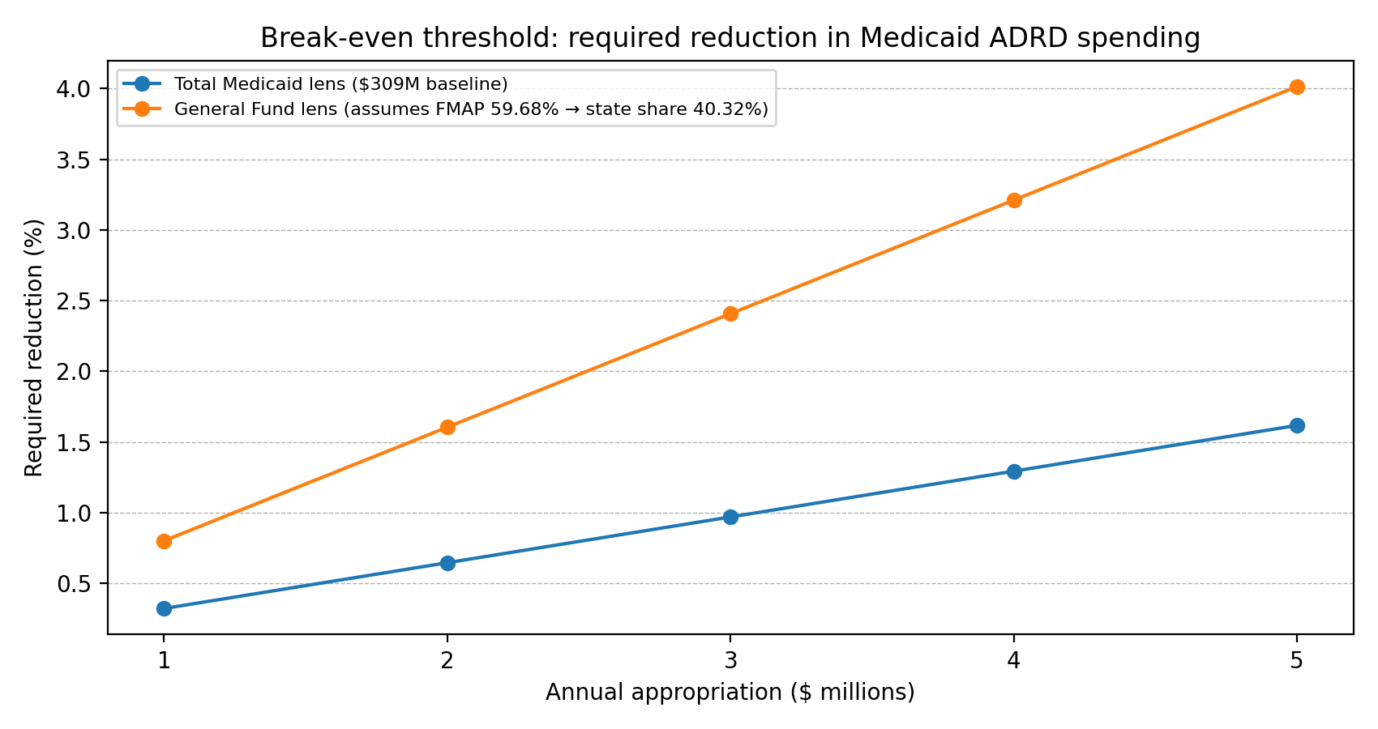
Figure (summary). Break-even threshold by appropriation level.

II. Program scope & guardrails

Recommended conditions
- A capped appropriation and clear definition of allowable recurring costs (avoid unapproved scope expansion).
- A one-page logic model showing how navigation + clinic partnerships drive reductions in avoidable ED/hospital use and delays in LTSS placement.
- A baseline measurement period and an attribution method (so savings claims are defensible).
- Quarterly dashboard reporting to staff + an annual report due 20 days before session (already contemplated in bill drafts).
- Equity requirements for neighbor islands (service levels and staffing coverage by county).

HANAI funds overview
HANAI should be described in “appropriation language”—clear scope, clear outputs, and clear accountability.

HANAI funds
- Dementia care navigation: intake, triage, care-pathway guidance, and warm handoffs to services.
- County-level access: dementia care specialists in every county and telehealth-enabled reach to neighbor islands.
- Clinical partnerships: contracts with providers/memory clinics to expand diagnostic and treatment access.
- Provider training/technical assistance to improve dementia competence statewide.
- Public-facing directory/website and community education (so families can find help before crisis).
- Data + evaluation capability sufficient to report outcomes and guide course-correction.

HANAI does not (unless explicitly authorized)
- Create an open-ended entitlement or unlimited service promise.
- Replace Med-QUEST benefits or clinical care that is already covered by Medicaid/insurers.
- Expand administrative overhead without measurable service-level targets (SLAs) and outcomes.
- Duplicate existing ADRC/AAA functions without a clear integration plan.

III. Fiscal logic WAM/FIN can defend
This section translates the appropriation into a simple break-even threshold. The intent is conservative: it asks only whether a modest reduction in Medicaid dementia costs could justify the appropriation, without double-counting household or health-system benefits.

Break-even equation
Break-even Medicaid reduction (%) = (Annual HANAI cost ÷ Annual Medicaid Alzheimer's/dementia spending) × 100

Break-even table using $309,000,000 Medicaid baseline
Annual HANAI cost | Break-even Medicaid reduction | One-line interpretation
$1,000,000 | 0.32% | Need about 0.32% less Medicaid dementia spend vs. $309M baseline
$3,000,000 | 0.97% | Need about 0.97% less Medicaid dementia spend vs. $309M baseline
$5,000,000 | 1.62% | Need about 1.62% less Medicaid dementia spend vs. $309M baseline
$10,000,000 | 3.24% | Need about 3.24% less Medicaid dementia spend vs. $309M baseline

Break-even visuals (committee-ready)
These visuals translate the break-even math into a quick scan for WAM/FIN. They use the $309M Medicaid ADRD baseline shown above. If staff prefer a General Fund lens, use the state-share line in the chart.

Figure 1. Break-even threshold by appropriation level (Total Medicaid vs General Fund lens).
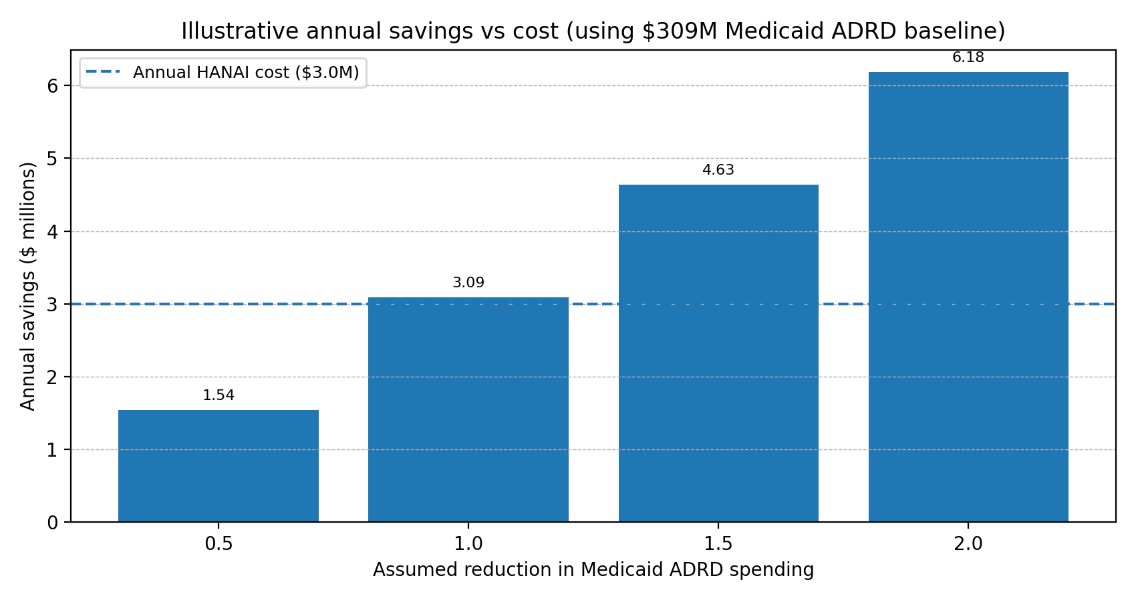
Figure 2. Illustrative annual savings vs annual HANAI cost at different savings assumptions.
Important fiscal note for WAM/FIN: If the committee prefers the General Fund lens, convert the Medicaid baseline to the State share (100% - FMAP). Hawaii's regular FMAP for FY 2026 is approximately 59.68%, meaning the State share is about 40.32%. Re-run the break-even using the State-share baseline if desired.

IV. Oversight package
The funding decision is not only about program support; it is also about reducing avoidable risk through better coordination and oversight. These guardrails make HANAI measurable and correctable.

Required reporting and decision checkpoints
- Quarterly dashboard (to committee staff): volume served, response time, county coverage, referrals, training delivered, spend-to-date by category.
- Annual report (statutory): activities, use of funds, and outcomes, due no later than 20 days before the regular session.
- Year-1 implementation review: confirm staffing, contracts, and service-level targets are operating as designed before scaling.

Minimum success metrics WAM/FIN can defend
- Access: median days from first contact to navigation plan; percent of callers receiving warm handoff.
- Equity: service availability and utilization by county (including neighbor islands).
- Utilization: change in ED visits and avoidable hospitalizations among enrolled/high-risk cohorts (claims-based).
- LTSS: change in rate/time-to long-term institutional placement among enrolled cohorts (claims-based where feasible).
- Caregiver support: standardized caregiver strain measure (survey) plus service utilization.

Risk register (FIN/WAM lens)
Appropriation committees typically focus on recurring risks like cost creep, weak attribution, duplication, equity gaps, and implementation delays. The table below pairs each risk with a mitigation/guardrail and a measurable indicator.
Risk | The Issue | Mitigation/guardrail | Control Metric
Cost creep / recurring cost escalation | Appropriations become permanent and grow beyond intent. | Cap admin %; define allowable expenses; phased ramp; require annual budget exhibit. | Spend vs cap; admin %; cost per person served.
Savings not attributable to HANAI | Hard to defend ROI in later sessions. | Define cohort + baseline + attribution method; use claims-based measures. | ED/hospital/LTSS metrics vs baseline/control where feasible.
Neighbor-island inequity | Program perceived as Oahu-only; political risk. | Minimum service levels by county; telehealth + partner clinics; transparent rollout. | Utilization and response time by county.
Duplication with existing programs | Perceived as bureaucracy instead of help. | Integration map with ADRC/AAA/Med-QUEST; defined handoffs and roles. | Referral completion rate; partner participation.
Implementation delays (procurement/workforce) | Funds appropriated but services delayed. | Clear procurement schedule; use 103F where authorized; early hiring/contract milestones. | Milestone completion; time-to-contract; vacancies.

Other Management and Controls
Parameter | WAM/FIN Importance
General Fund share of Medicaid baseline (State share vs total Medicaid) | WAM/FIN often evaluate savings on the GF lens; helps avoid debates over FMAP.
Line-item budget exhibit (Year 1 and steady-state) | Shows what is being purchased; prevents 'blank check' perception.
Staffing plan by county + partner sites | Demonstrates equity and readiness; answers 'who does the work, where'.
Procurement plan and readiness milestones | De-risks implementation; answers 'can this actually start this fiscal year?'

Measurement | WAM/FIN Importance
Integration/duplication map with ADRC, AAA, Med-QUEST, DOH, and nonprofits | Prevents objections that HANAI is duplicative bureaucracy.
Data and evaluation plan (baseline, cohort, attribution approach) | Makes future funding defensible and evidence-based.
Letters/MOUs from clinical partners and neighbor-island providers | Proves the network is real and ready to execute.

V. Key sources for verification
- Alzheimer's Association - Hawaii Alzheimer's Facts & Figures (2025 PDF): https://www.alz.org/getmedia/ae09dc00-0420-4f88-9096-43dfee72faaa/hawaii-alzheimers-facts-figures.pdf
- Alzheimer's Association Public Health Overview (Hawaii): https://www.alz.org/professionals/public-health/state-overview/hawaii
- LegiScan bill text - SB2589 (2026): https://legiscan.com/HI/text/SB2589/2026
- LegiScan bill text - HB1853 (2026): https://legiscan.com/HI/text/HB1853/2026
- MACPAC - FMAP by State (FY 2023-2026) (published Jan 2026): https://www.macpac.gov/wp-content/uploads/2026/01/EXHIBIT-6.-Federal-Medical-Assistance-Percentages-and-Enhanced-Federal-Medical-Assistance-Percentages-by-State-FYs-2023%E2%80%932026.pdf

VI. Appendix: Audit-ready equations & glossary
This appendix provides a glossary and equation rationale behind the break-even and savings estimates. It is included for legislative staff who want to audit assumptions and verify that the math is conservative and non-duplicative.

How to read the model
The model is built from simple 'how many times how much' math. Each equation multiplies:
- How many people HANAI serves (Participants).
- How often a costly event happens now (Baseline rate, like ED visits per person).
- How much the program reduces that event (Reduction percent).
- The dollar cost of that event (Cost per ED visit, cost per hospitalization, cost per month of long-term care).
Separately, the model asks whether the total expected benefits are larger than the program cost. That provides FIN and WAM with the essential information needed to evaluate the appropriation.

Glossary of terms
Term | Meaning & Interpretation | Importance | Source
HANAI Memory Network | A coordinated statewide dementia care navigation and memory clinic support system. | Defines the program being funded and evaluated. | Bill text, DOH/Med-QUEST program plan, contracts.
FIN / WAM | Legislative committees that decide whether to appropriate money and under what conditions. | They play a central role in determining whether State funding is provided. | Legislative process.
Medicaid | The joint federal-state insurance program for eligible residents; a major State budget line item. | Most dementia long-term care costs that hit the State show up here. | Med-QUEST claims and budget reports.

Term | Meaning & Interpretation | Importance | Source
LTSS | Long-Term Services and Supports: home care, nursing facilities, adult day health, and related services. | LTSS spending is where delayed placement can create large savings. | Medicaid LTSS claims and reports.
LTC placement | Entering a nursing facility or memory care setting for long-term residence. | Delaying placement by even a few months can save substantial dollars. | Claims, facility admission data.
ED | Emergency Department (the ER). | Avoidable dementia-related crises often drive ED use and costs. | Claims and hospital utilization data.
Hospitalization | An inpatient hospital stay. | Costs are high; preventing admissions and readmissions is a key savings lever. | Claims, hospital discharge data.
Readmission | A return to the hospital soon after discharge (often within 30 days). | Signals instability and gaps in care coordination; costly for payers. | Claims, hospital quality reports.
Length of stay | How many days someone stays in the hospital. | Shortening unnecessary days reduces cost and frees beds. | Hospital discharge data.
Participants | The number of people with dementia (and caregivers) actively served by HANAI. | Benefits scale with how many people you reach. | Program enrollment / referral counts.
Reach | What percent of the dementia population HANAI touches in Year 1/3/5 (example: 5% / 15% / 25%). | Defines growth expectations and prevents unrealistic savings claims. | Population estimates and program counts.

Term | Meaning | Importance | Source
Baseline rate | How often a costly event occurs without HANAI (e.g., ED visits per person per year). | A necessary starting point; savings are reductions from baseline. | Claims history, HHIC data.
Effect size / reduction percent | The percent change attributable to HANAI (low/base/high scenarios). | This is the core assumption FIN/WAM will challenge; ranges increase credibility. | Published studies, pilots, local data.
Time horizon | How many years you evaluate costs and benefits (commonly 5 years for budgets). | Some savings appear quickly (ED), others take longer (delayed placement). | Budget planning conventions.
Discount rate | A standard way to value future dollars slightly less than today's dollars (often 3%). | Used for longer-term projections; keeps analysis consistent with public finance practice. | Public finance guidance.
Attribution | How much change you credit to HANAI versus other factors (new drugs, policy changes). | FIN/WAM want conservative, defendable claims, not over-crediting. | Evaluation methodology.
Program cost | Annual cost to operate HANAI (staff, partnerships, tech, outreach, evaluation). | The appropriation request and the denominator for ROI. | Budget and contracts.
Net benefit | Total benefits minus program cost. | Tells whether the program is fiscally positive after paying for itself. | Calculated from model.

Term | Meaning | Importance | Source
ROI | Return on investment: Net benefit divided by program cost. | A single number committees recognize immediately. | Calculated from model.
Benefit-cost ratio | Total benefits divided by program cost. | A ratio above 1.0 means benefits exceed costs. | Calculated from model.
Break-even | The minimum improvement needed for benefits to equal program cost. | A powerful, simple threshold for decision-makers. | Calculated from baseline spend and cost.
Medicaid share percent | The percent of long-term care costs actually paid by Medicaid (not private pay). | Prevents overstating State savings when families pay part of the cost. | Claims mix, payer mix studies.

Equation rationale
These formulas estimate avoided costs. They do not claim that a single family is 'worth' a dollar amount. They simply convert fewer crises and delayed institutional care into budget terms.

A) Acute care savings
Avoided ED costs
ED_Savings = Participants × Baseline_ED_per_person × ED_Reduction% × Cost_per_ED
Interpretation: If HANAI serves a certain number of people, and each person would otherwise visit the ED a certain number of times per year, and HANAI reduces those visits by a certain percent, then multiply the avoided visits by the average cost per ED visit.
Avoided hospital costs
Hosp_Savings = Participants × Baseline_Hosp_per_person × Hosp_Reduction% × Cost_per_Hosp
Interpretation: Same structure as the ED formula, but for inpatient stays. Hospitals are expensive; even small percentage reductions can matter financially.

B) Long-term care savings
Delayed placement savings
LTC_Savings = AtRisk_Participants × Months_Delayed × Cost_per_Month × Medicaid_Share%

Interpretation: Focus on the subgroup most likely to enter long-term care soon. If HANAI delays entry by a few months, multiply the months delayed by the monthly cost, then multiply by the Medicaid share (because FIN/WAM care about the portion paid by the State).

C) Net benefit, ROI, and benefit-cost ratio
Net_Benefit = (ED_Savings + Hosp_Savings + LTC_Savings + other benefits) - Program_Cost
ROI = Net_Benefit / Program_Cost
Benefit-Cost Ratio = Total_Benefits / Program_Cost
Interpretation: Add up all estimated savings, subtract what the program costs, then compare the result to the program cost. ROI tells you the net gain per dollar spent. Benefit-cost ratio tells you total benefits per dollar spent.

D) Break-even (why it is so persuasive for FIN/WAM)
Break-even answers: 'How small of an improvement pays for the program?' If annual Medicaid Alzheimer's spending is about $309 million and HANAI costs $3 million per year, then:
Break-even reduction needed = 3,000,000 / 309,000,000 ≈ 0.0097 (about 0.97%).
Interpretation: If the program improves outcomes enough to reduce the Medicaid Alzheimer's cost trend by about one percent, the State breaks even. Anything better than that generates net fiscal benefit.

E) Common pitfalls & how the 'lens' approach prevents them
- Double-counting: Counting the same savings twice (for example, claiming both Medicaid savings and hospital savings for the same avoided hospitalization). Fix: keep separate lenses and only use one as the primary budget argument (usually Medicaid/LTSS).
- Using charges instead of costs: Hospital 'charges' can be much higher than actual costs or allowed amounts. Fix: use claims paid amounts or standardized cost estimates.
- Assuming everyone benefits equally: Savings are much higher when you target high-risk families. Fix: split participants into high-risk vs general and model separately.
- Over-crediting attribution: Other policy or treatment changes may also reduce costs. Fix: use conservative ranges and clearly state what is attributed to HANAI.
- Ignoring timing: Some benefits take longer to appear (delayed placement). Fix: present 1-year, 3-year, and 5-year views.

F) Quick FAQ
Are the benefits guaranteed?
- No. It is a disciplined estimate using explicit assumptions. The point is to fund HANAI with measurement and oversight so the Legislature can verify results.
Critical usage of Medicaid for FIN/WAM?
- Because Medicaid and LTSS are the largest State-controlled cost centers for dementia. Health system and household impacts are important, but Medicaid is the budget line committees manage.
Why require annual reporting?
- Reporting is the enforcement mechanism: it converts an appropriation into a measurable program with accountability and continuous improvement.

