STATE OF HAWAIʻI LEGISLATURE
HB1853 – HANAI Memory Network Program
Conference Outcome & Implementation Strategy
April 28, 2026
Prepared by The Sicilian Alzheimer’s Ambassador

Executive Summary
HB1853 marks a major turning point in Hawaiʻi’s dementia care strategy. With approximately $1.5M per year in funding, the State now has the opportunity to build a coordinated care model. However, the funding level requires a focused, data-driven proof of concept beginning on Oʻahu to ensure measurable outcomes and justify expansion.

Cost Escalation Model
Dementia-related events increase dramatically in cost when unmanaged.
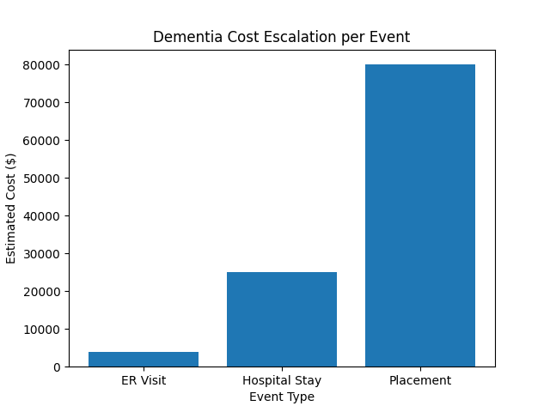

Proposed Funding Allocation
Recommended distribution of HANAI program funding.
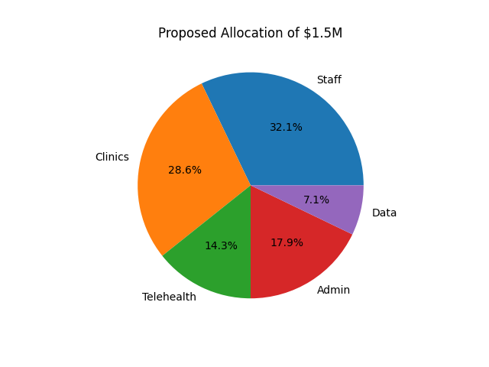

Implementation Timeline
Key milestones required to achieve proof of concept.
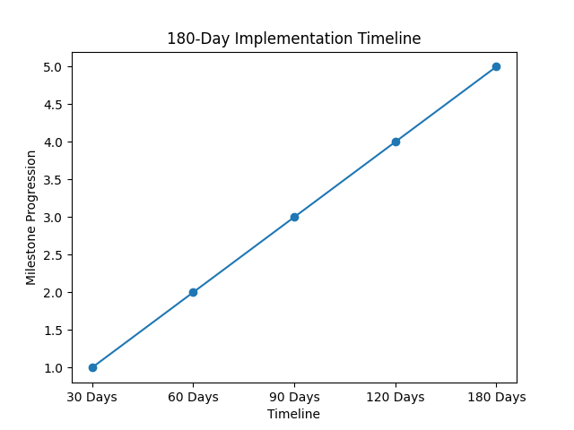

Legislative Arguments
• Hawaiʻi is already spending over $300M annually on dementia care.
• A 1% reduction in costs would fully fund HANAI.
• The current system is reactive and crisis-driven.
• HANAI enables early intervention and coordination.
• Oʻahu offers the fastest path to measurable results.
• Proof of concept enables expansion in 2027.

